GRAPH SKILLS TEST
Question #  & Source | Original Question | Turkish Version
1.  (TIMSS, 2007) | 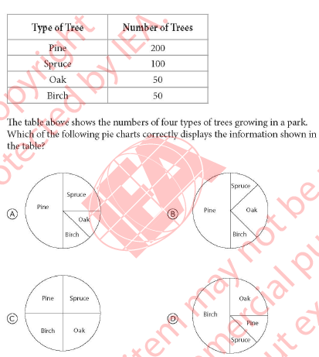
2.  (TIMSS, 2007) | 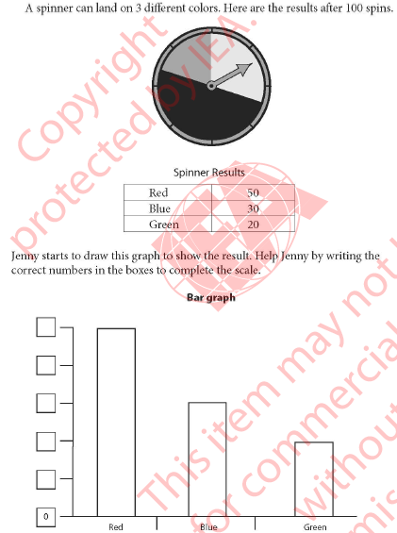
3.  (TIMSS, 2007) | 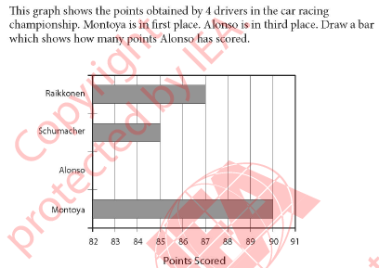
4.  (TIMSS, 2007) | 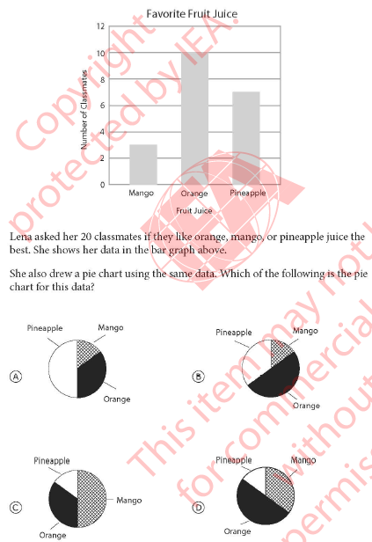
5.  (Authors) | 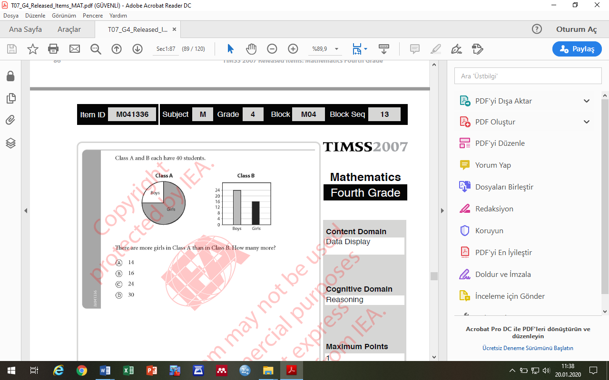  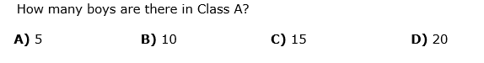 | 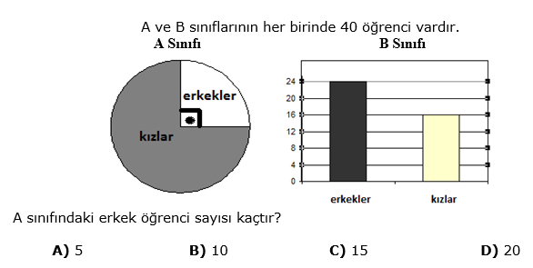
6.  (TIMSS, 2007) |  | 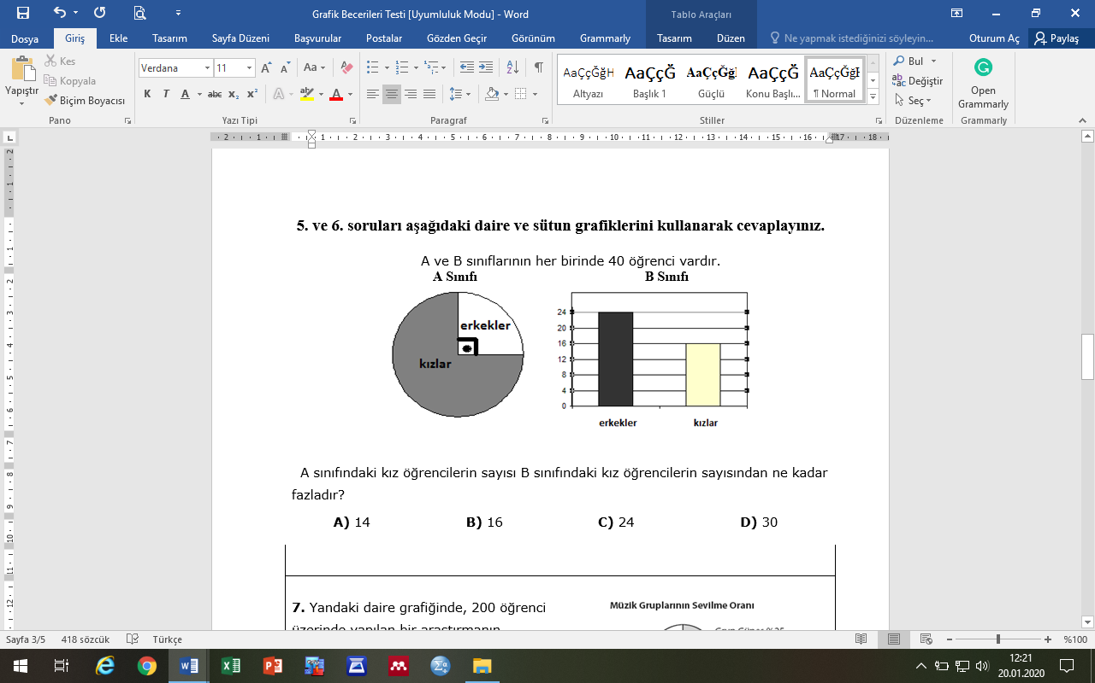
7.  (TIMSS, 2007) | 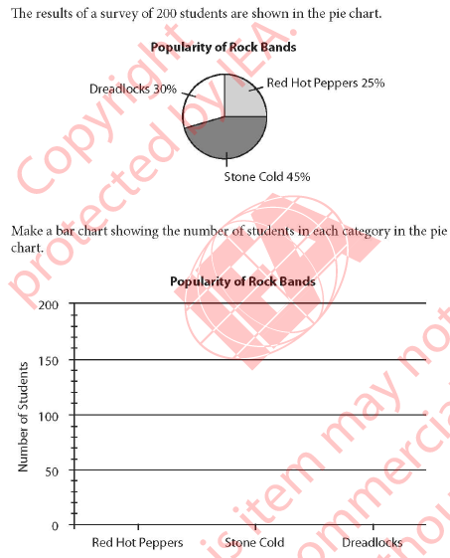
8.  (TIMSS, 2007) | 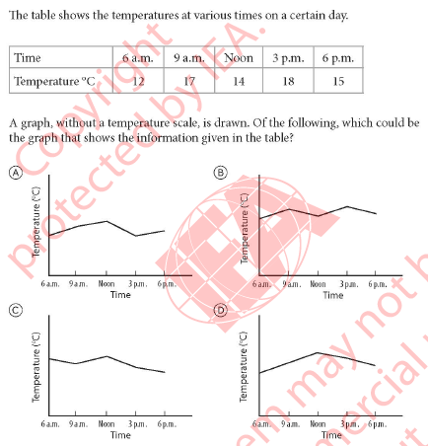
9.  (TIMSS, 2007) | 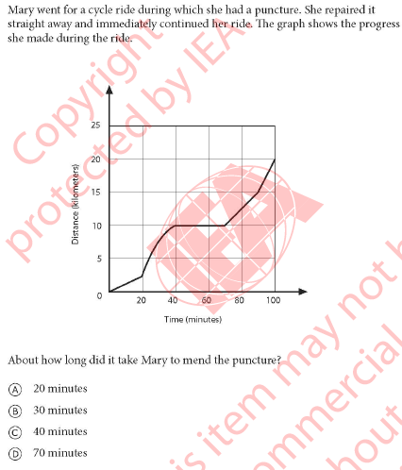
10.  (TIMSS, 1995) | 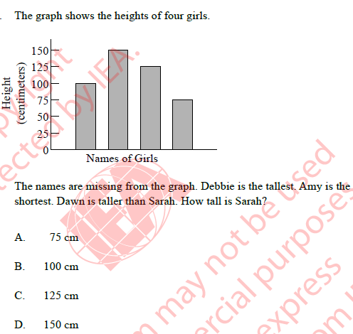
11.

(PISA, 2006)

