Graph Self-Efficacy Beliefs and Graph Attitudes (GSEBGA) Scale

Please read each of the following items and tick one of the options that best describes your opinions to indicate what you think about the graphs.

 | Strongly Disagree | Disagree | Agree | Strongly Agree
- I can’t formulate my ideas on graph questions. | □ | □ | □ | □
2. Graph questions in exams always worry me more than other questions. | □ | □ | □ | □
3. Graphs make it easier to learn the subjects in science courses. | □ | □ | □ | □
4. I can’t understand the graphs that involve more than two variables. | □ | □ | □ | □
5. I would like to learn new information about graphs. | □ | □ | □ | □
6. I can’t make analyses by looking at the numbers in graphs. | □ | □ | □ | □
7. I would like the numerical values in exams to be given in graphs rather than to be given in the text. | □ | □ | □ | □
8. When I see graph questions, I feel that I can’t solve them. | □ | □ | □ | □
9. Studying the graphs on books attracts my attention. | □ | □ | □ | □
10. I feel myself insufficient in interpreting the graph questions. | □ | □ | □ | □
11. I would have trouble when expressing data values in graphs. | □ | □ | □ | □
12. I enjoy working on graph questions. | □ | □ | □ | □
Notes for future Scale users:

Factor 1 (GSEB): Item 1, Item 2, Item 4, Item 6, Item 8, Item 10, Item 11

Factor 2 (GA): Item 3, Item 5, Item 7, Item 9, Item 12

Negative Items to be Reverse Coded: All items in the GSEB factor

Graph Literacy Perceptions according to Graph Types (GLPGT) Scale

- This scale is designed to get your views for each of the Line Graphs, Bar Graphs, and Pie Charts separately.

- Firstly, determine how you feel about the Line Graphs, Bar Graphs, and Pie Charts for each of the four items in the scale, according to the below Disagreement/Agreement categories with 1-4 number codes.

- Then, for each item, mark the number code (independently for each graph type) of the Disagreement/Agreement category, which best expresses your opinion about the Line Graphs, Bar Graphs, and Pie Charts.

1: Strongly Disagree
2: Disagree
3: Agree
4: Strongly Agree
 | 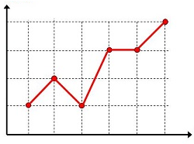 |  |  |  |  | 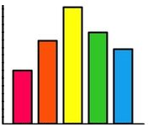 |  |  |  |  | 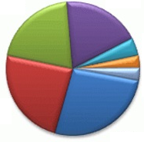
 | Line Graph |  |  |  |  | Bar Graph |  |  |  |  | Pie Chart
- I can display the given data correctly as a graph. | (1) | (2) | (3) | (4) |  | (1) | (2) | (3) | (4) |  | (1) | (2) | (3) | (4)
- I can correctly interpret the graphs. | (1) | (2) | (3) | (4) |  | (1) | (2) | (3) | (4) |  | (1) | (2) | (3) | (4)
- I like to present data in graphs. | (1) | (2) | (3) | (4) |  | (1) | (2) | (3) | (4) |  | (1) | (2) | (3) | (4)
- I can easily find the correct responses to graph questions. | (1) | (2) | (3) | (4) |  | (1) | (2) | (3) | (4) |  | (1) | (2) | (3) | (4)

Important Note: For each of the following four items, you are asked to give 3 separate answers, each independently indicating your thoughts about the Line Graphs, Bar Graphs, and Pie Charts.

