**1.** Find an equation of the line given the following information.

Passes through the point $(-3, 4)$    slope = $-\frac{3}{2}$

**2.** Find an equation of the line given the following information.

Passes through the points $\left(9, 3\right)$  and $(5, 1)$

**3.** Find an equation of the line given the following information.

  Passes through the point (-8, 6) and is parallel to the line $-x-2y=4$

**4.** Find an equation of the line given the following information.

Passes through the point (6, -2) and is perpendicular to the line $3x-2y=-4$

**5.** Write the equation of the line pictured.

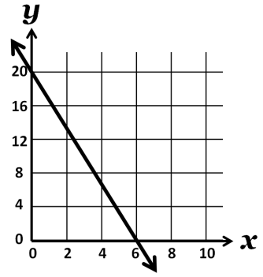

**6.** Write the equation of the line pictured.

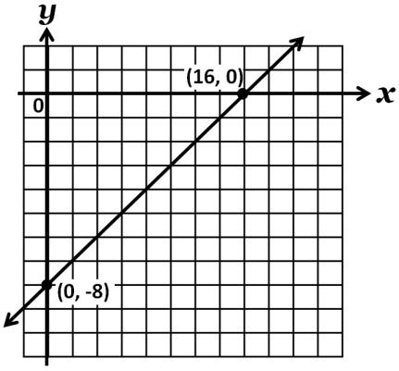

**7.** For the graph below, write the equation of the line and **interpret** in terms of the problem situation.

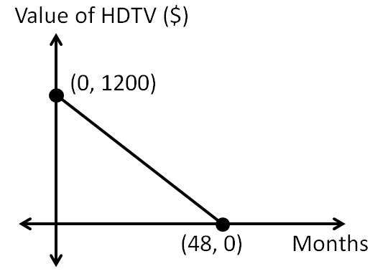

**8.** For the graph below, write the equation of the line and **interpret** in terms of the problem situation.

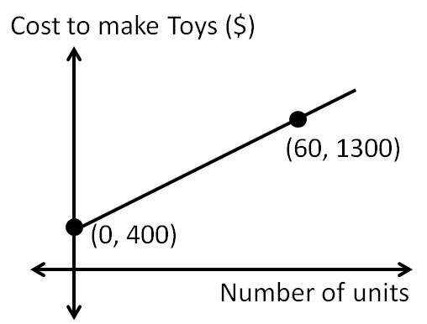

**9**. Use the data in the table to write a linear function equation.

|  |  |
| --- | --- |
| ***x*** | ***y*** |
| -4 | -10 |
| 0 | 2 |
| 3 | 11 |
| 5 | 17 |

**10.** Use the data in the table to write a linear function equation.

|  |  |
| --- | --- |
| ***x*** | ***y*** |
| -6 | 22 |
| 3 | 1 |
| -9 | 29 |
| -12 | 36 |

**11.** Determine whether the graphs of the following equations are parallel, perpendicular, or neither.

$2x-y=-6$

$4x-2y=12$

**12.** Determine whether the graphs of the following equations are parallel, perpendicular, or neither.

$3x+3y= -12$

$3x-3y=12$

**13.** Sketch a line contains the point (-2, 5) and has slope -2

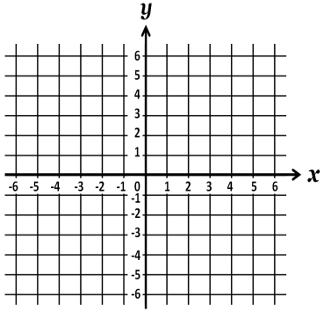

**14.** Sketch the graph using any method. $y=-\frac{4}{5}x+4$



**15.** Sketch the graph using any method. $2x-3y=-12$

