Video episodes | Description | Types of evidence
1st video (3.00 min.)  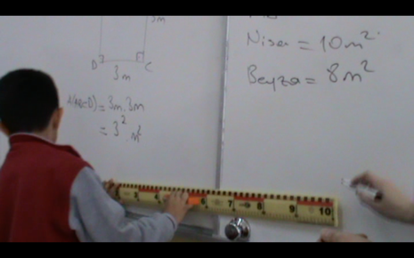  Area Measurement  (Grade 5)  Whole class discussion | - The teacher asks the students "Can we calculate the area of the board in square meters?" The whole class answers yes.  - The teacher tells the students to guess before measuring the area of the board. She writes the predictions of six students on the board (50m², 25m², 20m², 5m², 10m², 8m²).  - The teacher votes on which guess is better. Most students vote for 5m².  - The teacher mentions that the first three guesses are big fields. She then asks how they can calculate the area of the board.  - A student measures the side lengths of the board using a ruler and calculates the area of the board as 3m.1m = 3m².  - At the end of the lesson, the student asks how to measure large areas such as the ocean. | Short response  Short response  Voting  Action/  Mathematical notation  Question | Whole class  Individual student  Whole class  Individual student  Individual student
2nd video (4.33 min.)  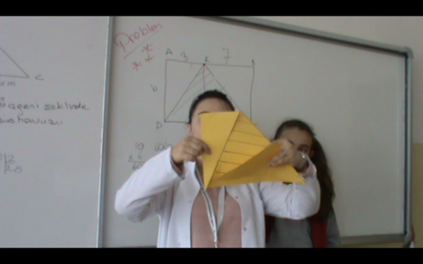  Area of Triangle  (Grade 6)  Whole class discussion | - The teacher asks the students to draw the shape on the board on colored paper and asks what kind of a relationship is between the areas of the triangles.  - Students cut the triangles. A student shows two right triangles by placing them on the other triangle and explains the relationship between their areas as the sum of the area of the two right triangles is equal to the area of the other triangle.  - The teacher shows the figure to the class again and asks if the student's answer is correct.  - This time, the teacher asks the students about the relationship between the area of the big triangle and the area of the rectangle. A student shows the area of the triangle and the area of the rectangle on the board by performing mathematical operations.  - Another student glues the right triangles on top of the other triangle and explains by showing the congruent triangles that the area of the larger triangle is half the area of the rectangle. | Action/  Explanation  Short response  Explanation/  Mathematical notation  Action/  Explanation | Individual student  Whole class  Individual student  Individual student
3rd video (3.36 min.)  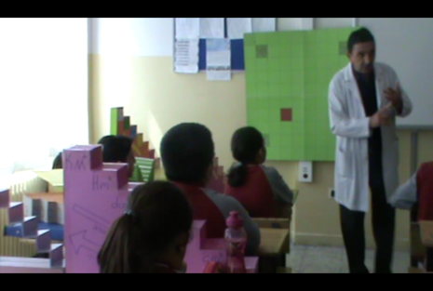 Area of Measure  Whole class discussion | - The teacher introduces the students to the floors and floors of a square meter and to the students, "Why do you think we use the floors and floors of a square meter? asks the question.  - Students want to have a say. The student responds that big places need big sizes, small places need small sizes.  - The teacher asks the question of whether we can measure large areas in square meters. The whole class gives different answers as yes or no. Asks the students to explain.  - A student who answers we cannot measure says that large areas are not measured by square meters. (Gives a map example)  - A student who says we can measure makes a statement based on length measures. (He says it is possible but difficult to measure the distance between two cities with meters)  - The teacher asks the students to vote for these two answers. Most students say it can be measured.  - The teacher makes instructional explanations and asks the students why they use submultiples of a square meter. A student replies, to be able to measure small areas.  - Can't teacher measure small areas in square meters? Asks the question. The whole class responds differently.  - The teacher asks why they could not measure. A student tries to measure his notebook with the square meter on the board and measures by counting the square decimeter.  - Meanwhile, a student asks, asking how the areas of the oceans can be measured. | Explanation  Short response  Explanation  Explanation  Voting  Short response  Short response  Action/  Explanation  Question | Individual student  Whole class  Individual student  Individual student  Whole class  Individual student  Whole class  Individual student  Individual student
4th video (4.25 min.)  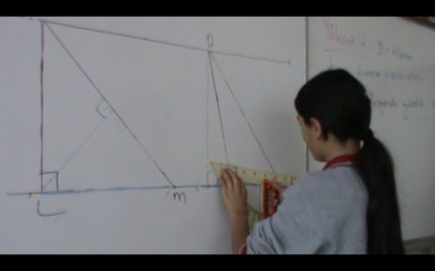  Height of the Triangle  (Grade 6)  Whole class discussion | - The teacher draws acute-angled, right-angled and broad-angled triangles between two parallel lines with the same heights of the lower base. Asks the students for the definition of height.  - A student takes the floor and makes an erroneous definition using the phrase "from corner to corner".  - Another student makes the definition of "a line drawn from one corner to the opposite side."  - The teacher makes instructional explanations by emphasizing on the wrong definitions of the students. She shows how she draws the heights of a narrow angle triangle using a set square.  - She asks students to draw the height of the right-angled triangle side KL. A student comes to the blackboard and shows it by drawing over the LM edge.  - The teacher asks the students about the height of the LM side. The whole class answers KL.  - The teacher gives a student the right to draw the height of the KM side. The student draws and explains the height using the square.  - The teacher asks the students to draw the heights of the wide-angle triangle. A student draws the height of the OR side incorrectly. (Tries to draw from corner R.)  - Meanwhile, a student asks a question. (Can we draw a perpendicular to an outside corner from the P?)  - Another student said, "Is there a stitch from R to O?" asks the question. | Explanation  Explanation  Action  Short response  Action/ Explanation  Action  Question  Question | Individual student  Individual student  Individual student  Whole class  Individual student  Individual student  Individual student  Individual student
5th video (3.30 min.)  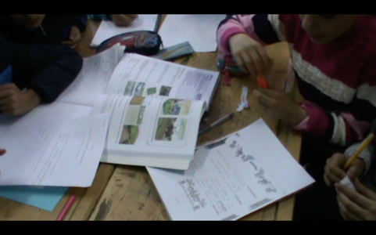  Land Measurement Units  (Grade 6)  Collaborative group work | - The teacher tells the collaborative learning groups to solve the land calculation problem contained in the worksheet.  - The teacher gives the students time to understand the problem and asks the groups if they understand. The groups respond as we understood or did not understand.  - The teacher travels between the groups and asks them to explain what is given and what is desired in the problem.  - The teacher asks the groups to have a say in explaining the strategies they have developed for the solution of the problem. The first group shows the solution strategy on the worksheet.  - The teacher checks the solution strategies of the other groups that have a voice and gives the group that uses a different solution.  - The teacher notices the wrong solution of one of the groups. She asks the students in the group to check the solution. The students showed the relationship between area and square meter incorrectly. (It was written as 1 m² = 100 a)  - The teacher raises one of the students in the group to the blackboard and asks him to solve the problem. While doing the addition, the student made a mistake because he did not write the steps one after the other. | Short response  Explanation  Explanation  Explanation/  Mathematical notation  Explanation/  Mathematical notation | Whole class  A particular group  A particular group  A particular group  Individual student
6th video (3.54 min.)  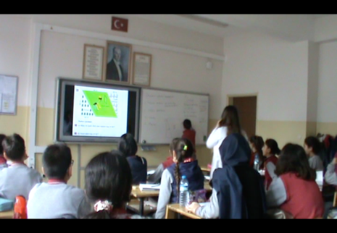  Areas Problems  (Grade 6)  Whole class discussion | - The teacher shows the compound area question prepared as a slide from the smart board. He asks the students what planar shapes they identified in the question.  - A student says that the woodland and flower garden are triangular.  - The teacher asks the student what kind of triangle she calls. The student answers the right triangle.  - The teacher asks the students what other shapes they see. The whole class gives the answer parallelogram.  - The teacher asks which area is a parallelogram. The whole class gives the playground answer.  - The teacher asks the students how they decide that the playground is parallelogram. A student makes an erroneous explanation by saying that the given shape is similar to a parallelogram.  - The teacher asks what properties it must have in order to be a parallelogram. A student explains the properties of parallelogram.  - The teacher asks the student to come to the blackboard and draw the figure.  - The student draws the shape and calculates the side lengths of the playing field by using the properties of the rectangle and sees that they are different.  - The teacher makes instructional explanations and asks the students how they found the forest area. A student says that the perpendicular edge multiplies the height of that edge.  - Another student answers that the perpendicular sides are the thing of the triangle.  - A student who says he is wrong explains that the forest area is half the product of the steep sides. | Explanation  Short response  Short response  Short response  Explanation  Explanation  Mathematical notation  Explanation  Explanation  Explanation | Individual student  Individual student  Whole class  Whole class  Individual student  Individual student  Individual student  Individual student  Individual student  Individual student

