Pilot Study

We conducted a pilot study of a limited number of course sections to validate the feature changes described before full-scale implementation. During pilot implementation, we collected data from student attitudinal surveys, student exam performance, and student discussion responses. This pilot study focuses on descriptive statistics because the course had changed significantly and the study was quasi-experimental, so inferring to the population would not be appropriate.

The control group had 520 students across 11 sections. The intervention group had 152 students across 3 sections. The course ran for 5 weeks. The control and intervention offerings started in late October 2019.

The following exploratory data was collected:

- Student experience was elicited via:
  - A stress survey with 8 questions, shown in (APPENDIX), was administered 1 week before the midterm (week 2 of the course).
  - A stress survey with 6 questions, shown in (APPENDIX), was administered 1 week before the final (week 4 of the course).
- Student scores on the midterm and final exams. Exam scores of zero were excluded, unless the student had worked on an assignment that week, indicating the student had really earned a zero. The raw scores were converted to a percentage for ease of interpretation.
- The attrition rate, i.e., the percentage of students earning an F grade in the course or withdrawing from the course.
- Student perceptions were from both student responses to discussion questions and weekly student surveys. Both were analyzed for emergent themes.

Results

The midterm stress survey means are shown in Table 5. Note that the intervention’s mean was better than the control’s mean for every question, except Enough Resources.

Table 5: Midterm stress survey questions’ mean (standard deviation) response. Higher is better, except for Midterm Anxiety and Class Anxiety. Better means are bolded.

Question label | Control (N=76) | Intervention (N=51)
Midterm Anxiety | 3.9 (1.0) | 3.7 (1.1)
Midterm Confidence | 2.5 (1.1) | 2.8 (1.1)
Class Enjoyment | 3.6 (1.0) | 4.0 (0.9)
Class Anxiety | 3.5 (1.1) | 3.1 (1.2)
Class Approachable | 3.6 (0.9) | 3.9 (0.9)
Enough Resources | 4.0 (0.9) | 3.9 (1.0)
Courseware Success | 3.9 (0.7) | 4.0 (0.8)
Text Understanding | 3.4 (0.8) | 3.8 (0.8)

The final stress survey questions are shown in Table 6. Note that the intervention’s mean was better than the control’s mean for every question, except Course Confidence wherein the mean was the same. Also note that many students who dropped or stopped before the final stress survey would not have taken the stress survey, suggesting the difference between control and intervention may be even higher due to more attrition among control students (discussed further below).

Table 6: Final stress survey questions’ mean (standard deviation) response. Higher is better, except for Final Anxiety and Struggle. Better means are bolded.
Question label | Control (N=60) | Intervention (N=54)
Final Anxiety | 4.0 (1.0) | 3.7 (1.3)
Final Confidence | 2.6 (1.0) | 3.0 (1.2)
Open | 4.1 (0.9) | 4.3 (0.9)
Important | 4.0 (0.8) | 4.1 (1.0)
Struggle | 3.4 (1.1) | 3.0 (1.1)
Course Confidence | 3.3 (1.0) | 3.3 (1.1)

The midterm and final exam scores are shown in Table 7. In both, intervention students performed better than the control students. Interestingly, on the final exam, 94% (491/520) of the control students attempted the final, whereas 99% (150/152) of intervention students did.

Table 7: Student scores on the midterm and final exams. SD means standard deviation.
Exam | Control | Intervention
Midterm | N=485, mean=72, SD=30 | N=149, mean=78, SD=17
Final | N=467, mean=70, SD=26 | N=147, mean=82, SD=19

Figure 4 shows the letter grade distribution of the final exam for the control and intervention. Students in the intervention tended to have more A’s, whereas students in the control tended to have more C’s, D’s, F’s, and non-attempts.

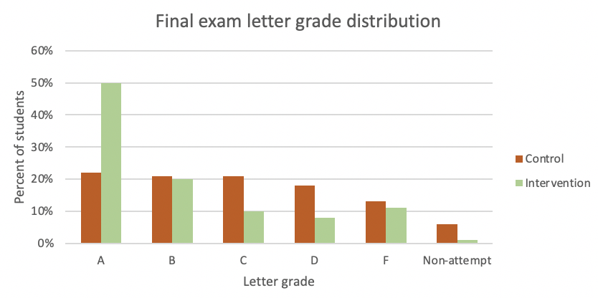
Figure 4: Distribution of final exam letter grades in the control and intervention. Students in the intervention had a much higher percentage of A’s than students in the control.

The control offering’s attrition was 14.6%, whereas the intervention’s attrition was 5.3%.

We also tracked the students that passed the control and intervention offerings to identify whether student success persisted into subsequent courses. We focused on degree seeking students, who are actively enrolled in an eligible program to obtain a bachelor’s degree, as such students are expected to have subsequent courses.

Table 9: Persistence in subsequent courses of degree seeking students who passed QR1.
Condition | Students passed QR1 | Students passed QR2* in following term | Students passed next course** after QR2 in subsequent term
Control | 402 | 297 (73.9%) | 295 (73.4%)
Intervention | 109 | 96 (88.1%) | 95 (87.2%)
*Does not include students who may have enrolled in a different course on the following start date
**Students third course was determined by their respective degree programs

As shown in Table 9, control students were less likely to pass QR2 (73.9%) in the following term than the intervention students (88.1%). This is interesting because even students who passed the control version of QR1 behaved differently than students who passed the intervention.

Summary

The pilot data showed that student attitudes and outcomes improved. This contrasted strongly with the historical data, which supported a decision to move forward with changes, and implementation across all sections of QR1 and QR2 was pursued. Each planned action is discussed in subsequent sections.

Changes for Future Iteration
As a result of information collected as part of the pilot study, minor modifications were made to update the course materials. Faculty feedback was used to enhance some of the mathematical concepts introduced in the course readings.

Additional directions for students were included to support their navigation through specific course features as a result of student feedback. Naming conventions of assignments were modified to promote clarity. While none of these changes were large, by themselves, the pilot information supported their implementation to best maximize the student and faculty experience.

