**Appendix**

Appendix A: Interview Protocol

*Turn on the Kinect program. Make sure the program registers the student. The screen will likely be pink.*

Ok, now we are going to do an activity using the Kinect. I need you to stand right about here for the activity *(place an x on the floor 6-8 ft from the Kinect sensor with masking tape, if needed).*

In this activity, you only move your arms, and you only move them out to the side, with your elbows and wrists straight, your body stays still and your arms move around, you can move your arms across your body—close into your body. Do you see how the screen is changing colors? *(Demonstrate for a relatively long time, move your arms, one at a time, both at the same time etc. Ask the student to try moving their arms around the way you are describing. Remind them not to bend their elbows or move their arms in front of their body.) Verify that the student understands.*

*There are not that many rules to this game. The rules are:*

1. *Your body stays straight*
2. *Your arms are straight at elbows and wrists*
3. *Move arms all around, keeping them out to your side. Like you are pressed against a big glass window, so they can’t go in front of you.*
4. *You can move one arm across your body, but you have to keep them tight to your body with your elbows and wrists straight.*

*Use the colors that the student names, for example purple might be used instead of pink.*

*(As the student is moving their arms wait until the screen is some color other than pink, then ask the first question—is possible. If you ask about Pink and they can’t find it, ask them what colors they see.)*

Q: Will you tell me how you can make the screen Pink?

*(The student will likely make the screen pink and provide some verbal response.)*

*If the student says “like this” or the response is unclear follow-up with a question – I don’t understand. Can you tell me more?*

*Level of persistence for questioning: Move on once you feel satisfied that the student has explained their thinking to the level of depth they are capable of at that moment.*

Q: Can you find another way to make the screen Pink? *(The student will likely make the screen pink in a new way.) If the student does not give an explanation, ask a follow-up question. I don’t understand. (Can you tell me in another way?) Only ask them one time to make pink a different way.*

*Note to the interviewer: Try to move slowly through the interview. Be patient and encourage the student to talk as much as possible, particularly early on. Give them plenty of time to explore the activity space. Provide positive feedback as necessary. For example, oh, I see what you mean* or *oh, I understand*. *(Aim for comments that are less about right or wrong and more about the fact that you understand the students’ thinking.) Also, particularly if the student is shy you may want to try repeating back what the student said.*

Q: Can you tell me what you would do to make the screen yellow?

*(The student will likely make the screen yellow and provide some verbal response.)*

*If the student says “like this” or the response is unclear follow-up with a question. I don’t understand . (Can you tell me in another way?)*

*Other potential follow-up questions:*  *Can you tell me a little bit more about that? I’m not sure I understand* *or* *I’m not sure what you mean. Can you describe what you are doing in a different way?*

Q: Can you find another way to make the screen yellow? *(The student may make the screen yellow in a new way.) If the student is unable to find another way to make the screen yellow you can move on. If they find another way but don't explain what they did, ask a follow-up question. What did you do make the screen yellow that time? Only ask them one time to make yellow a different way.*

*Repeat these steps for light blue and dark blue.*

*Use follow-up questions for understanding and ask for a second way to make the screen the given color for each of these.*

I’m going to add an angle to the screen that will help you build on your ideas. Each time we add more information, we’re going to ask you about your thinking. Ok, now try moving your arms around again.

*(Add the angle with the smallest arrows)*

Q: What do you notice about the angle? *(Pause to* *give* *them* *time* *to* *experiment*).

Q: Can you explain to me how to make the screen pink?

*During this stage you should be asking follow-up questions:*

* Can you tell me a little bit more about that? I’m not sure I understand. What is the angle doing?
* I’m not sure what you mean. Can you describe what you are doing in a different way? What is the angle doing?
* *What do you mean by like this? What is the angle doing?*
* *Could you tell (the other person in the room) how he/she could make the screen pink? What is the angle doing?*

*Do not ask about a second way to turn the screen a color.*

Repeat these steps for yellow, light blue, and dark blue*.*

Have you used a protractor before? This is a protractor *(turn on the protractor).* A protractor is used to describe the size of an angle. This number *(point to the angle measure on the screen)* is called the angle measure and tells you the size of the angle. We would say this angle is 45 degrees *(or whatever angle measure appears on the screen at this point)*.

I have to go check on something quickly in the hall. While I’m gone play around with the protractor and see what you find out. *(Give them about 30 seconds)*

Q: What did you notice about the protractor?

Q: Can you explain to me how to turn the screen Pink?

*During this stage you should be asking follow-up questions:*

* *What do you mean by like this?* Can you describe how to make the screen pink using the angle measure?
* *Could you tell (the other person in the room) how he/she could make the screen pink?* Can you describe how to make the screen pink using the angle measure?
* Can you tell me a little bit more about that? I’m not sure I understand. Can you describe how to make the screen pink using the angle measure?
* I’m not sure what you mean. Can you describe what you are doing in a different way? Can you describe how to make the screen pink using the angle measure?

*During this stage you should NOT ask them to show you another way to make the screen a certain color.*

Repeat these steps for yellow, light blue, and dark blue.

We are going to add one more thing to the screen.(add the longer arrows) What did we do?

Ask about each color.

Ok, you did a great job explaining your thinking during the activity. I have one last question. If we invited a first or second grader into the room and asked you to explain this, what would you say?

Appendix B: Pre-assessment

*One question was presented to students at a time.*

1. Degrees tell you the size of an angle. Draw an angle that is 90 degrees.
2. Degrees tell you the size of an angle. Draw an angle that is 30 degrees.
3. Degrees tell you the size of an angle. Draw an angle that is 150 degrees.
4. Degrees tell you the size of an angle. Draw an angle that is 180 degrees.
5. Estimate the size of this angle.

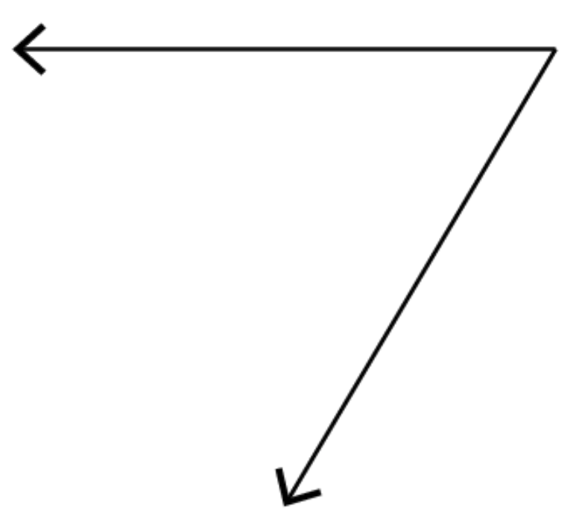

1. Estimate the size of this angle.

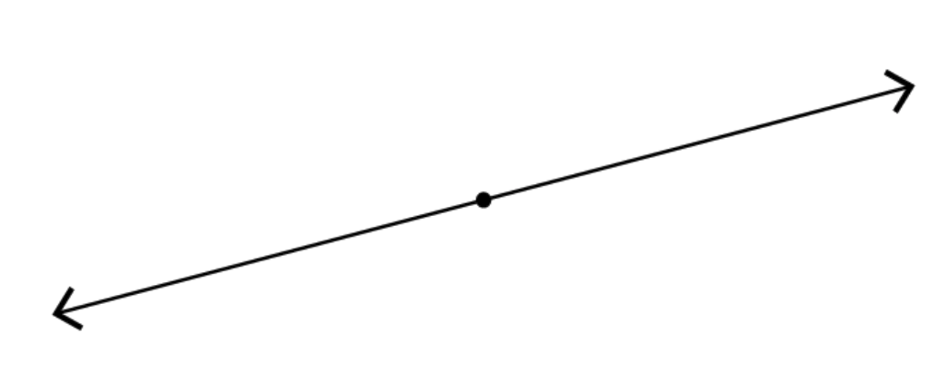

1. Estimate the size of this angle.

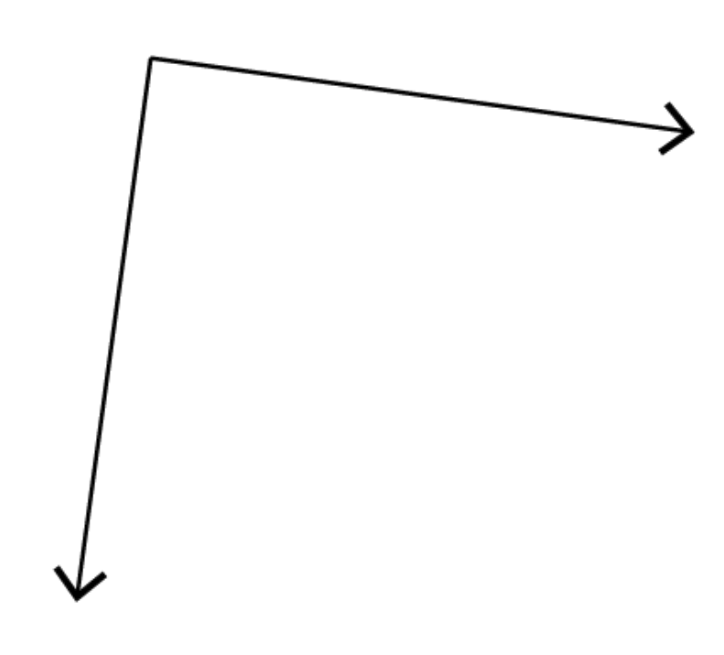

1. Estimate the size of this angle.

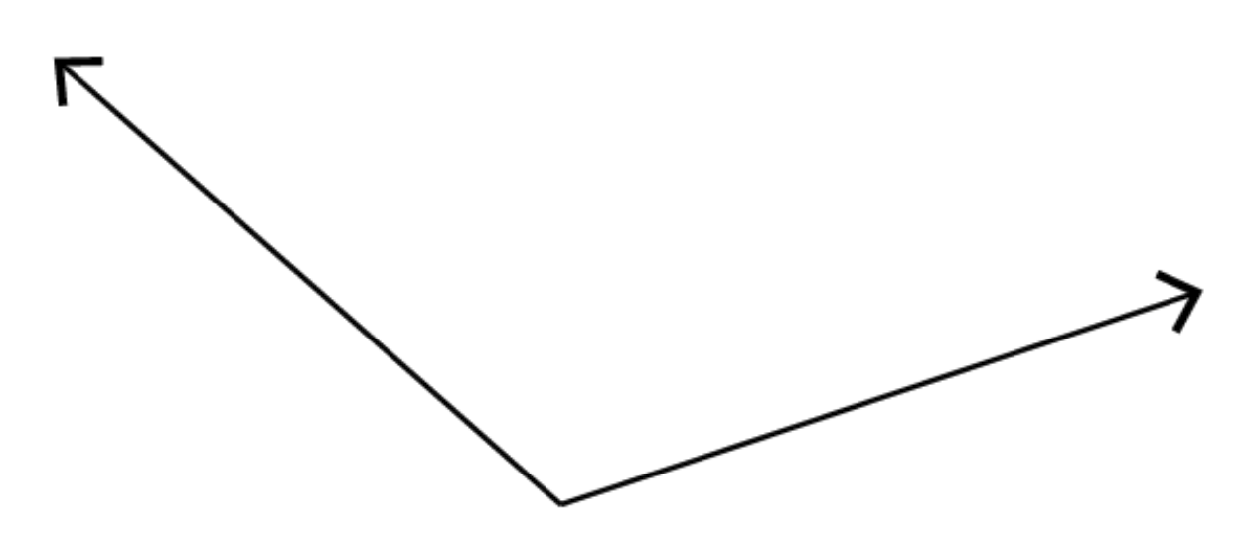

Appendix C: Spatial Words used in the Study

|  |  |  |  |  |
| --- | --- | --- | --- | --- |
| a lot |  | further |  | position |
| above |  | half(way) |  | rhombus |
| across |  | high |  | same |
| apart |  | left |  | shape |
| below |  | a little |  | side(ways) |
| between |  | less |  | small |
| big |  | low |  | square |
| bottom |  | middle |  | straight |
| by |  | more |  | to |
| center |  | much |  | together |
| circle |  | near |  | top |
| close |  | opposite |  | triangle |
| down(ward) |  | out(ward) |  | turn |
| far |  | over |  | under |
| flat |  | part |  | up(ward) |
| from |  | past |  | wide |
|  |  | point |  |  |