Fostering Peer Evaluation and CAP Domains in School Level Science Education: A Critical Reflection on the STEAM Approach
Sudarsan Limbu
Article Info |  | Abstract
Article history |  | In this study, the implementation of a STEAM project was critically examined, with constructivist grounded principles utilized to inform the perspective of both a learner and a STEAM practitioner. A comprehensive project plan was devised that incorporated CAP domains through the integration of the STEAM praxis with peer and self-assessment strategies for school-level science education. This innovative approach, aimed at nurturing the aesthetic value in arts and the evaluation process, led to the creation of a unique methodology for assessing students’ cognitive and psychomotor skills. The framework for accessing students’ peer/self-evaluation via meticulously designed rubrics is further highlighted. The implementation of a project plan proved to be an interactive and insightful process, fostering a profound understanding of students’ concerns and interests. This study underscores the transformative potential of the STEAM approach in educational settings, highlighting its role in promoting critical thinking, creativity, and problem-solving skills among students.
Keywords
Peer Evaluation,
Critical Reflection,
Science Education,
STEAM Approach,
CAP Domains,
Teacher and Student Wellbeing

Introduction

In recent years, Nepal's educational landscape has witnessed a significant shift towards innovative teaching methods and curriculum reform. This transformation aims to enhance the quality of education and equip students with the skills required in the 21st century. One notable approach at the forefront of this educational revolution is the STEAM (Science, Technology, Engineering, Arts, and Mathematics) methodology. The STEAM approach represents a departure from traditional teaching practices and seeks to integrate diverse disciplines, fostering a holistic and transdisciplinary learning experience (Menin & Testa, 2021). In Nepal, this approach is still in its nascent stages, signifying an exciting and rapidly emerging concept (Belbase, 2020). The overarching goal is to reshape educational practices, from curriculum design to teaching methodologies.

Robertson (2022), drawing from the insights of ADB (2017), has eloquently emphasized the need for a paradigm shift in how teaching and learning are conceived in Nepal. In the traditional model of education, teachers are positioned as knowledge depositors, and students passively receive and reproduce information. This aligns with Wang’s (2022) traditional classroom concept, where discipline is enforced and teachers control the class. However, this teacher-centered approach, focusing on book knowledge and a controlled environment, often results in poor assessment outcomes and lack of problem-solving skills among students (Jin et al., 2021; Wang, 2022). It also tends to overlook the importance of nurturing students’ unique abilities.

To address these challenges and usher in a new era of education, this study embarks on a critical reflective design journey. It endeavors to expose the transformational potential of the STEAM approach and its impact on learners. At its core, this research seeks to implement a comprehensive lesson plan tailored for tenth-grade students, one that is firmly grounded in the principles of Cognitive, Affective, and Psychomotor (CAP) domains of learning incorporating the peer evaluation system. However, the transformational journey extends beyond the adoption of a novel curriculum. It calls for a fundamental shift in the dynamics of the classroom. Drawing inspiration from Yew and Goh (2016), who advocate for active, self-motivated, cooperative, and context-based learning, this study aspires to break down the traditional hierarchy in the teacher-student relationship. The aim is to cultivate a collaborative and democratic classroom environment that fosters student-centered learning.

Defining the Issues: Purpose of the study

This study explores the teaching of meiosis, a complex cell division process, which is challenging for students due to its intricacy and the lack of adequate real-life visualization tools, especially in the context of Nepal (Dhamala et al., 2021). Meiosis, occurring in sexually reproducing organisms, involves two nuclear fissions and results in four gametes, each with half the number of chromosomes of the original cell. It comprises two distinct divisions: meiosis I and meiosis II, with DNA replication preceding these divisions.
Previously, my teaching approach, aligned with conventional methods, viewed students as passive knowledge recipients and teachers as the primary information sources (Fitzgerald & Smith, 2016; Koirala, 2021). This approach, characterized by direct instruction and emphasis on rote memorization, has been criticized for its inability to foster critical thinking and problem-solving skills among students (Fitzgerald & Smith, 2016; Belbase, 2020).

It’s been observed that many students frequently doubt the aesthetic value of their own ideas and abilities due to a lack of practice. This self-doubt and lack of confidence often lead them to prematurely discard their concepts, such can be overcome by providing aesthetic education, as suggested by Wang (2022). In this study, I investigate the theoretical and practical implications of integrating the STEAM approach within the Nepalese educational context to frame the students’ arts. This approach aims to enhance students' understanding of meiosis through peer collaboration, multi-dimensional perspectives, hands-on activities, and inquiry-based interaction. Furthermore, it incorporates the CAP domains integrated with self/peer evaluation in school-level science education as Yang et al. (2016) found that effective teaching strategies can significantly foster students’ creative thinking in science. This study contributes to the ongoing dialogue on education reform and offers valuable insights for educators, policymakers, and researchers by sustaining the principles of verisimilitude (Graham, 2013) and pedagogical thoughtfulness (Herodotou et al., 2019). Therefore, the central research question of this study is:
- How has the STEAM approach been implemented in my professional practice to foster CAP domains and Peer/Self-Evaluation?

Philosophical Consideration

The STEAM approach is an interdisciplinary educational approach that integrates Science, Technology, Engineering, the Arts, and Mathematics to promote student inquiry, dialogue, and critical thinking. According to Perales and Aróstegui (2021), the movement to promote the development of Science, Technology, Engineering, and Mathematics (STEM) originated in the United States in the 1990s under the sponsorship of the National Science Foundation. In 2007, Georgette Yakman published her research-backed philosophy on STEAM Education and developed the STEAM education framework based on STEM education. Her team also designed the STEAM teaching process card and established a certification program for STEAM education training (Menin & Testa, 2021).

STEAM education incorporates the arts and humanities into the core curriculum alongside scientific and technological disciplines. Land (2013) notes that traditional STEM degrees focus on convergent skills and Art degrees emphasize divergent skills. A STEAM approach can bridge this divide and provide a more integrated educational experience. Perales and Aróstegui (2021) further note that this approach encourages students to take calculated risks, engage in experiential learning, persist in problem-solving, collaborate with others, and navigate the creative art practices and their values. Following these, this study provides an overview of the STEAM approach through a recent project that I conducted.

Theoretical Review

The fusion of Pragmatism and Transformative Learning theory offers a unique perspective on education and personal development. Pragmatism, as proposed by Peirce, James, and Dewey, emphasizes the practical implications of ideas (Kelly & Cordeiro, 2020). This can be integrated with the transformative learning theory, which focuses on personal growth (Kitchenham, 2012). Together, they form a comprehensive framework for enhancing education. This pragmatic perspective aligns with the practical solutions required in education, such as the STEAM approach. On the other hand, the transformative learning theory, developed by Mezirow, is centered on personal growth and development, especially in adult education (Kitchenham, 2012). While this theory recognizes the importance of individual change, it has been criticized for not addressing societal power imbalances (Fleming, 2022).

However, when integrated with Pragmatism, the Transformative Learning theory can provide a balanced approach. By emphasizing the cognitive, affective, and psychomotor domains within the STEAM approach, this fusion aims to transform teaching practices at the same time, considering personal perceptions and practices within the teaching profession. The thematic framework proposed by Tippett and Lee (2019) in the context of progressive learning incorporates the elements of pragmatism, action learning, transformative learning, and continual learning, providing a well-rounded perspective on modern education. Additionally, the deep learning framework introduced by Fayek et al. (2020) complements these themes by addressing challenges in continual learning, further enhancing the progressive education landscape.

In conclusion, the fusion of Pragmatism and Transformative Learning theory offers a coherent framework that combines practicality, collaborative problem-solving, and personal growth to enhance education, particularly in the context of the STEAM project. This comprehensive approach considers both the practical consequences of ideas and the transformative potential of personal development, addressing the needs of students and educators alike.

Expedition of the Study:

Narration on Nurturing STEAM Notions and Themes for this Study

My career in science education commenced during my BSc studies, evolving concurrently with my academic progression. The pivotal moment for the pedagogical conceptualization was my enrollment in the MPhil in STEAM Education, a decade into my career. Initially, my pedagogical approach was conventional, emphasizing rote memorization and exam performance, as characterized by Fitzgerald and Smith (2016).

Transitioning to the STEAM teaching approach marked a significant shift in my pedagogical philosophy. This approach, proven effective by Holbrook et al. (2020) and Bertrand & Namukasa (2020), emphasizes multi/inter/trans-disciplinary learning and skills. I now prioritize diverse delivery methods for concept inculcation, mirroring Ozkan and Topsakal (2021), which has positively impacted student learning and misconception rectification. As Quigley et al. (2020) suggest, my teaching now incorporates project-based, arts-based, and technology-based methods, fostering 21st-century skills.

Reflecting on my MPhil journey, the courses that most influenced my understanding of STEAM Pedagogy advocated for a project-based approach, incorporating CAP domains and peer evaluation. This transformation has not only revolutionized my teaching methods but also enhanced my students' learning experiences, promoting a more comprehensive and interactive approach to science education.

Teaching and Learning in STEAM: The Course STEAM ED 630

This pedagogy-oriented course, segmented into four modules, primarily focuses on mastering the STEAM teaching approach. It has been an illuminating journey, introducing a variety of teaching methodologies and prompting critical self-reflection on our practices in the context of past experiences and beliefs. The course initially introduced three teaching approaches (Fenstermacher & Soltis, 2009, p.5):
- The ‘Teacher as Executive’ approach, positions the teacher as a classroom process manager, utilizing evidence-based methods to achieve learning outcomes.
- The ‘Facilitator Approach’, values students’ prior experiences and emphasizes personal growth and self-understanding.
- The ‘Liberationist Approach’, envisions the teacher as a liberator of the learner’s mind, fostering a well-rounded, knowledgeable, and moral individual.
Several group tasks facilitated our pedagogical evolution through the lens of Transformative Learning Theory, involving introspection, addressing pedagogical dilemmas, adopting new perspectives, and integrating them into our practice (Şahin & Doğantay, 2018). The course provided a comprehensive understanding of constructivist, sociocultural, transformative learning perspectives, and experiential learning. Throughout this course, we engaged with several relevant journals, but two, in particular, significantly influenced my professional life. Gauthier (2014) presented seven research-based principles for understanding student learning, emphasizing the importance of understanding students’ prior knowledge, organization of knowledge, motivation for learning, mastery development, goal-directed practice, feedback, interaction of students’ current development level with the course climate, and development of self-directed learning skills. Shulman (2005) explored signature pedagogies, distinctive teaching and learning forms that prepare individuals for their professions, playing a crucial role in professional socialization and nurturing cognitive, practical, and moral dimensions of professional work.

Three Domains of Learning: The three domains of learning, cognitive, affective, and psychomotor, are integral to pedagogical processes. The cognitive domain, as per Bloom's revised Taxonomy (2000-01), involves the development of intellectual abilities and skills, categorized into six levels: Remembering, Understanding, Applying, Analyzing, Evaluating, and Creating (Mohammed & Omar, 2020). The affective domain, according to Krathwohl’s Taxonomy (1964), pertains to emotions, feelings, and attitudes, and is divided into five levels: Receiving, Responding, Valuing, Organizing, and Characterizing. Teaching methods incorporating emotionalized learning experiences significantly impact students' academic achievement (Green & Batool, 2017). The psychomotor domain, as per Harrow’s taxonomy (1972), involves physical movement and coordination and includes six levels. Incorporating teaching strategies that address this domain in practical teaching is crucial (Ahmad et al., 2018). Adding to this, Hoque (2016) emphasizes the interconnection of these domains in the teaching and learning process, which can facilitate holistic learning outcomes. Holistic learning encompasses content-specific thinking ability, communication skills, and the reflection of creative cognition through hands-on skills. Sönmez (2017) suggests a strong correlation between cognitive, psychomotor, and affective learning outcomes. The taxonomies of these domains provide a framework for constructing lessons that engage different learning domains, aiding in the development of a range of skills. The aim is to develop a lesson plan incorporating these dimensions within the context of STEAM Education.

Art-based Pedagogy: This course emphasized the integration of arts into standard teaching practices. Through comprehensive readings, we developed our arts-based pedagogy, informed by the insights of Jacob (2022), Sousa et al. (2022), and Hunter and Frawley (2023). Sousa et al. (2022) underscored the interplay between sociology, critical pedagogy, and artistic practices, especially in art-based research application and analysis. A colleague's experience of artistically representing data to respect the identities of underprivileged research participants was particularly impactful, highlighting the potential of art to illuminate participant narratives in a meaningful way.

In the context of school students, the course fostered discussions around arts-based pedagogies, exploring identities and cultivating dispositions through art processes such as creating, responding, performing, and developing pedagogies based on music, painting, drama, and poetry. Jacobs (2022) and Hunter and Frawley (2023) stressed that integrating arts-based approaches into education provides innovative engagement methods for students with course materials, promoting more effective interventions and a deeper understanding of social reality.

Formative Assessment Supported by Peer Evaluation: The course explored various assessment methods, emphasizing the importance of student learning evaluation. Formative assessment, an ongoing process used by teachers and students to provide feedback and adjust teaching and learning (Andrade, 2010; Ozan & Kıncal, 2018), is integral to this process. It aims to enhance students' understanding and achievement of learning goals, providing progress information and identifying areas needing additional support. Integrating formative assessment into our evaluation system is crucial for a comprehensive and effective assessment of our methodologies (Grob et al., 2021). Research indicates students' preference for teacher feedback over peer assessment, although they are interested in providing feedback (Zlabkova et al., 2021). Peer assessment has progressively improved students' proficiency in scientific writing (Yang et al., 2019), and when provided with clear evaluation criteria, peer assessments become significantly more reliable (Mariya, 2005).

Formative assessment, typically informal and low-stakes, takes various forms, including quizzes, discussions, observations, and peer/self-assessments (Suzanne & Margaret, 2021). It primarily guides instruction and provides feedback, empowering students to recognize their strengths and weaknesses, monitor their progress, and take ownership of their learning.

Methodology

This study is informed by the teachings from the course: STEAM ED 630. The ideas and learnings from this course have been implemented in this study, which is guided by a constructivist paradigm as suggested by Bogna et al. (2020) to gain deeper insights. This paradigm emphasizes the importance of personal meaning-making and the active construction of knowledge through experience. Furthermore, this study examines the effectiveness of the ideas learned during the course when they are implemented in a Constructivist Grounded Theory design. In this design, I critically acknowledged that my experiences and perspectives can influence the interpretation of the data and the development of the theory (Burns et al., 2022). From the next perspective, this study appears identical to the action research where I intervened by the course, unlearned the existing conventional approach, and learned the STEAM approach (George, 2023). In addition, I utilized statistical analysis to assess the consistency of the mean difference in scores between the teacher and students during peer evaluation. Consequently, this investigation is characterized by a mixed-methods approach, and the Figure 1 illustrates the conceptual framework of this method. The qualitative component scrutinizes the influence of CAP domains of learning, while the quantitative segment evaluates the reliability of scores during peer assessment. This was my practice to examine and frame for valuing students’ participation in the evaluation process.

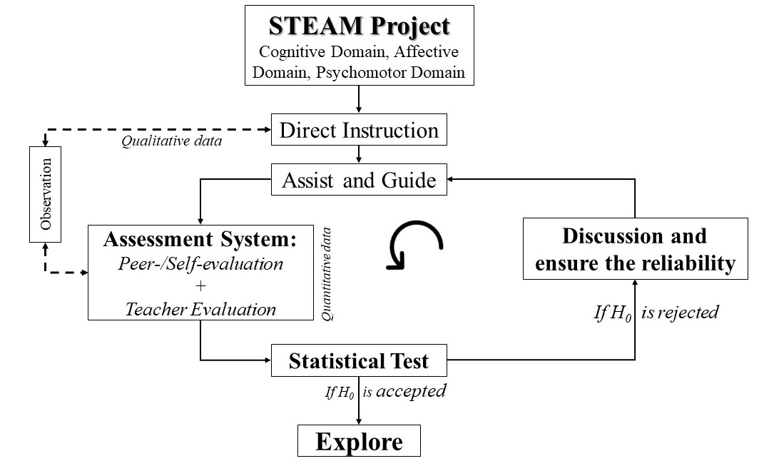
Figure 1: Conceptual Framework of this Study

The situations I study possess multiple realities and it is based on a relativist ontology, where I explore the conceptual schemes owned by myself and students believing that reality is socially constructed (Denzin & Lincoln, 2013). Moreover, this study follows a subjectivist epistemology, where I worked together with students to generate knowledge. I understand that meanings are linked to dialogue and social interactions, as stated by Peters et al. (2013). In line with the approach, I gathered data through natural discourses, where I acted as an observer and recorder (Denzin & Lincoln, 2013) to identify and formulate themes and concepts from them.

Ethical Considerations & Quality Standard

Post initial verbal communication, formal approval was obtained from the university, enabling the implementation phase. During this phase, key events were meticulously documented through photographic evidence and observational recordings, minimizing potential influences on participant behavior to ensure study integrity (MacNeill et al., 2016). Upon project completion, stakeholders were informed of the intent to publish an article (Palmer, 2021), and students provided written consent and data. This study adheres to rigorous quality standards and contributes to the dialogue on effective science teaching methodologies.

Guided by authenticity and pedagogical thoughtfulness, the study aims to provide a comprehensive understanding of the implementation process, observations, and assessment outcomes in teaching meiosis. It ensures authenticity and a deep understanding of lived experiences through careful lesson planning, considering diverse learning needs (Graham, 2013), and thoughtful integration of Cognitive, Affective, and Psychomotor domains in STEAM teaching. The study addresses the concept of verisimilitude and pedagogical thoughtfulness (Herodotou et al., 2019), emphasizing continuous reflexivity among science teachers

Implementing STEAM Education:

A Narrative Reflection on Project-Based Teaching

[This project was conducted to address the three domains (Cognitive, Affective, and Psychomotor) in the STEAM approach along with the peer evaluation to teaching science content. The whole project plan for implementing it developed the following narration.]

Critically reflecting and based on the insights from the course and the project we implemented remote site of Dapcha village, I developed a lesson plan and assessment rubric and introduced it to my tenth-grade students on Friday. The goal was to ensure that arrived prepared with all necessary materials (chart paper, modeling clay, colored sketch pens, glue sticks, and evaluation guidelines) on the following school days. The primary objective of this plan in Table 1 was to teach the introduction and significance of Meiosis cell division using the STEAM approach and incorporating CAP domains with a peer assessment system.

Table 1: STEAM Project Plan
Grade: Ten
Teaching hours: Two teaching periods (90 minutes)
Lesson: Meiosis Cell Division
Project Title: Understanding Meiosis Through STEAM Approach
Objective: Students will be able to understand the process of Meiosis cell division and its importance in genetic diversity.
Key Methodology: Incorporating the STEAM approach and three domains of learning (Cognitive, Affective, and Psychomotor).
General ideas to address three domains of knowledge
Cognitive Domain: | the cognitive domain is addressed through activities such as direct instruction, where students learn about the steps of Meiosis cell division and its importance in genetic diversity, and independent practice, where students create a clay modeling or comic strip to illustrate their understanding of the process
Affective Domain: | the affective domain is addressed through activities such as the introduction, where students are encouraged to share their prior knowledge and thoughts about cell division, and the closure, where students reflect on what they have learned and share their work with the class.
Psychomotor Domain: | the psychomotor domain is addressed through activities such as guided practice, where students work in pairs to create a model of Meiosis cell division using modeling clay or playdough and pipe cleaners or chenille sticks.
Materials:
- Diagrams and images of Meiosis cell division
- Modeling clay
- Chart papers, pencils, sketch pen, glue
Comprehensive plans for the implementation:
Respective disciplines and domains will be highly focused
Day: One
Introduction (5 minutes) | - -Begin with icebreaking interaction by inquiring students what they know about cell division and its importance in living organisms.  -- Introduce the concept of Meiosis and explain that it is a type of cell division that produces gametes (sperm and egg cells) with half the number of chromosomes as the parent cell.
Direct Instruction (20 minutes): SCIENCE and TECHNOLOGY for COGNITIVE Domain | - -Use diagrams and images to explain the steps of Meiosis cell division, including Prophase I, Metaphase I, Anaphase I, Telophase I, Cytokinesis, Prophase II, Metaphase II, Anaphase II, Telophase II, and Cytokinesis.  - -Emphasize the importance of genetic diversity and how it is achieved through the process of crossing over during Prophase I.  - Use interactive simulations or animations to help students visualize the process of Meiosis cell division.
Guided Practice (20 minutes): ARTS and ENGINEERING with AFFECTION and PSYCOMOTOR Domains | - Divide total students into two groups randomly; Group A: Clay model and Group B: Comic strip  - Encourage students to design the final model and divide tasks equally as possible  - Encourage students to use their creativity and artistic skills to make their clay modeling and comic strip visually appealing.  - Encourage students to use different colors to represent different chromosomes and to show the process of crossing over during Prophase I, and other changes also.
If any responsible task is left, they can take it as a home assignment.
Day: Two
Independent Practice (15 minutes): MATHEMATICS and TECHNOLOGY with AFFECTION Domain | - students create a comic strip and a clay model that illustrates the steps of Meiosis cell division.  - Have students calculate the probability of different genetic outcomes resulting from the process of Meiosis and crossing over.  - Use mathematical models to represent the Meiosis process and help students understand the concepts of genetic diversity and inheritance.  - Use online resources, such as videos or articles, to supplement your instruction and provide students with additional information about Meiosis.
Closure (30 minutes):  Presentation | - Ask students to share their models and comic strips with the class.  - Review the key concepts covered in the lesson and ask students to reflect on what they have learned and give feedback.
Assessment: | - Observing students' participation during class discussions and their ability to create accurate models and comic strips.  - Evaluating students’ understanding through inquiry or interaction in their presentation following the objectives.  - Use of rubrics (Figure 4a and 4b) to assess students' understanding of Meiosis cell division and their ability to apply STEAM concepts and incorporate the three domains of learning.  -Teacher’s evaluation and Peers Evaluation (Inter/Intra group and the Self)

On the initial day, I engaged the class in an interactive session to activate their prior knowledge of amitosis, mitosis, and meiosis cell division processes (Virtue et al., 2019; Bitterman et al., 2023). Some students participated, outlining the roles of these processes in cellular reproduction, organ growth, and gamete formation. I appreciated their input and further elaborated on meiosis using a detailed diagram, noting the textbook’s lack of clarity in depicting phase-wise chromosomal changes. The class, consisting of twenty-two students, was then provided with color-printed diagrams of complete meiosis cell division. Following a 25-minute introductory session, I divided the class into two groups, Group A (Clay modeling) and Group B (Comic strip), based on their roll numbers. Each group comprised eleven members

The students were encouraged to discuss the provided figure and assigned task and collaborate on the design before assigning individual tasks. I observed good collaboration among group members, with students taking responsibility for one phase each. I acted as a resource for ideas and assisted with color selection and design however, they were well-prepared and designed their group task using online resources. The students’ progress was regularly observed as they created models and drew comic strips. They were observed helping each other and striving to do their best. However, they had to be reminded to lower their voice during the discussion.

As Gilbert (2012) suggests, such a role of facilitating ideas for concepts and materials embodies an instructional pattern where a series of actions is undertaken by both educators and learners. This pattern includes a variety of activities such as disseminating information, assessing, motivating, guiding, planning, actively listening, reading, engaging in dialogues, debating, reflecting, predicting, asking questions, designing, and distinguishing different viewpoints. When these activities are integrated, they form a holistic and effective learning environment (Gilbert, 2012). This understanding was further reinforced through the detailed use of imagery of meiosis division. This is how I facilitated the addressing of the Cognitive Domain for Remembering, Conceptualizing, Analyzing, and Creating their respective models of Meiosis cell division, as pedagogically supported by Mohammed and Omar (2020).

 | 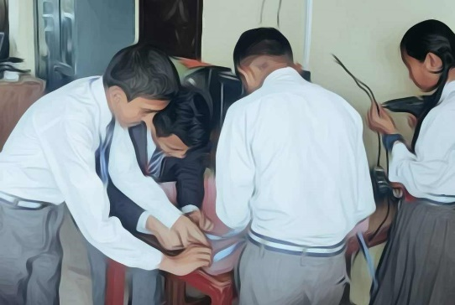
Figure 2: Students are engaging in group collaboration to design their assigned task

In this session, the prime focus was on the disciplines of Science and Technology, with an emphasis on the combined domain of cognitive and affective learning. This approach not only enhances students’ understanding of complex scientific concepts on meiosis division but also fosters a sense of relationship and responsibility towards the project (Michael, 2008; David & Katrien, 2011). While sharing ideas and supporting individual roles and work divisions for the project, I was grounded in the lines of David and Katrien (2011) that, the affective domain significantly influences students’ interest in learning, which has the potential to enhance student learning, foster a deeper understanding and application of major concepts and ideas, and reduce student attrition. Throughout this session, I was more active in shaping their project by addressing the Cognitive domain at first and then integrating it with the Affective domain for their group collaboration.

The class period ended before the tasks were completed according to the designed plan and with challenges. Therefore, the students were urged to finish their part of work at home and bring it back the next day moreover, they were encouraged to seek additional ideas or information from online resources.

On the subsequent day, students arrived with their work-in-progress and were guided to cooperate and integrate their tasks into a unified project. Both teams collaborated to bring their project to completion. During the self-guided practice session, I took on a more observational role, yet I noticed disputes arising as each student argued that their idea was the best for the assembly process. Drawing on the concepts discussed by Guy et al. (2015), I applied the affective domain significantly here to urge them to work together with minimal disagreements and to incorporate mathematical concepts into their representation of meiosis by formulating an equation for the count of chromosomes and their respective probabilities. In this early session of the day (connection between Hand, Head, and, Heart), I emphasized the Psychomotor and Affective domains in the line of Agi et al. (2018) to foster a connection between their cognitive understanding, physical actions, and emotional engagement.

Following me, they started conceptualizing the Meiosis cell division in groups such as presenting the number of chromosomes between parent and daughter cells in a tabular or informative format to explain why meiosis is known as reductional cell division and why organisms have even numbers of chromosomes. Approximately after fifteen minutes of collaboration, the students combined their work into a single chart and were encouraged to make it more visually appealing using colorful sketches as shown below for the presentation and evaluation process.

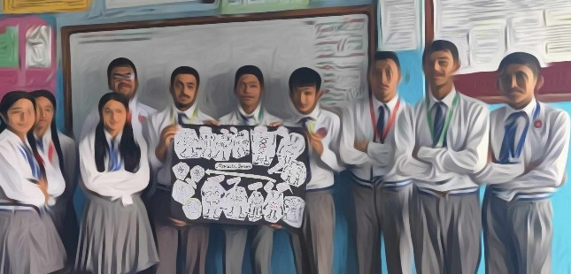 | 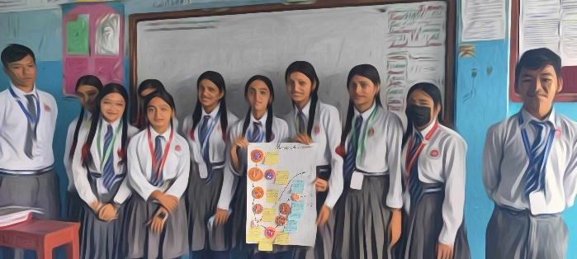
Figure 3: Students showing their group project
Note: Group- A presenting their Comic strip of meiosis cell division. | Note: Group- B presenting their clay modeling of meiosis cell division

Assessment of the project work.

In the context of assessment, the initial phase involved monitoring students’ collaborative efforts and participation. This observation process started at the very beginning of the implementation phase. It aimed to evaluate how well students worked together, their engagement level, and their active involvement in the learning process. According to Strijbos and Wichmann (2018), such practice is a continuous and integral part of the learning process. This part of the assessment provided immediate feedback, allowing for adjustments in teaching strategies and enhancing student learning outcomes.

The second part involved group presentations following the rubrics as Figure 4a and Figure 4b. Drawing the importance of rubrics in peer assessment as explained by Wolf and Stevens (2007), I considered rubrics as the central part of this second part assessment through which students are guided for the peer-/self-assessment and my assessment on them during the presentations. I further take the stance that by making expectations explicit, rubrics serve as a guide for instructional design, enhance the accuracy of assessments, and provide a tool for self-evaluation and peer feedback (Wolf and Stevens, 2007; Brookhart, 2018). Rubrics promote student learning by maintaining focus on key learning targets and ensuring assessment consistency.

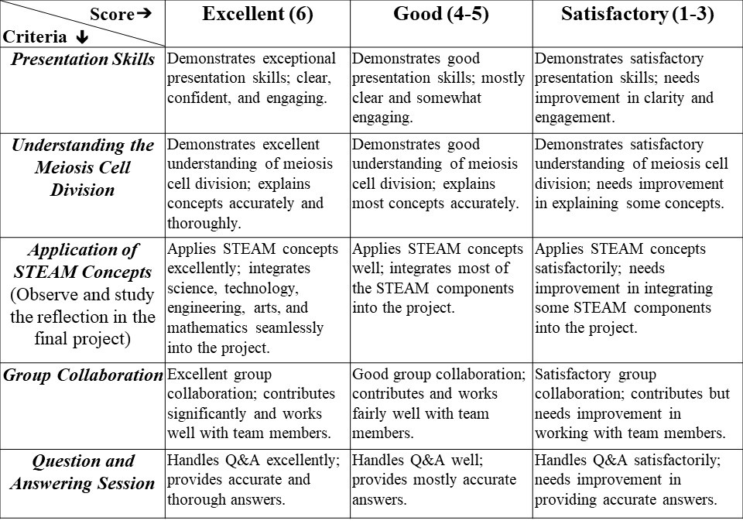
Figure 4a: Rubric to frame the Peer-Evaluation
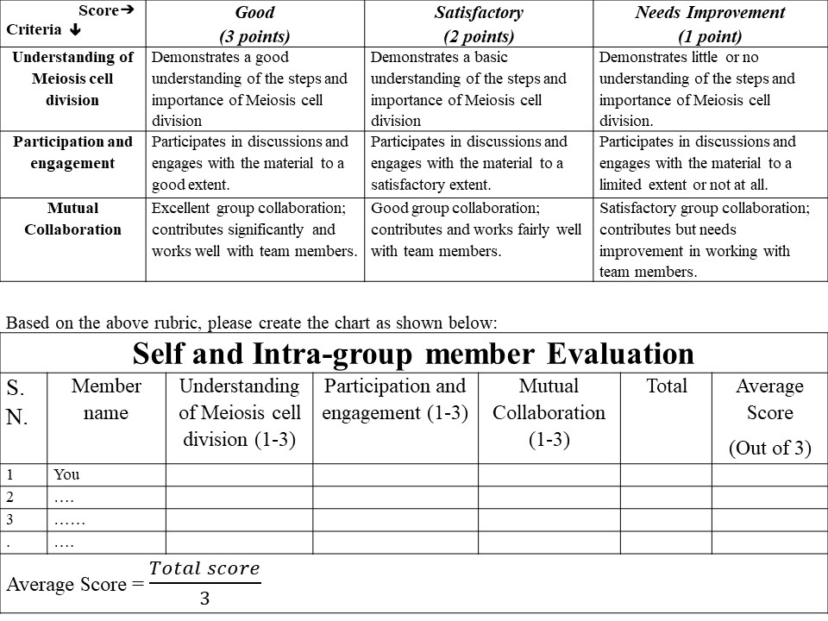
Figure 4b: Rubric to Frame the Self and Intra-group Evaluation

Note: Rubrics to evaluate the self and intra-group members were provided prior to the project begun.
* Scores from the peer-evaluation were to explore whereas from the self and Intra-group members were to keep confidential.

Each group was given ten minutes for their presentation and defense. Both groups presented well on topics such as phase-wise changes in chromosomes, synapsis, crossing-over, differences between Anaphase I and Anaphase II, the number of chromosomes in parent and daughter cells, and how cell division helps regulate the number of chromosomes. The scenarios were full of interaction between the presenter and the evaluator group guided by the provided rubric, such that the evaluator group criticized and the presenter defended.

The third part of the assessment involved peer and self-evaluation. This is a method where students assess their work (self-evaluation) and the work of their peers (peer evaluation). In this context, students evaluated both their team members (intra-group in Figure 6) and members of other teams (inter-group in Figure 5a-b). The evaluation was based on their presentation and defense sessions, as well as their collaboration and contribution to the project added by teacher’s evaluation and feedback (in Figure 7). This encourages students to critically analyze their work and that of others, fostering a deeper understanding of the subject matter. Such approaches of peer assessment are supported by Ndoye (2017) and it further argues that these are the processes by which students believe that peer and self-assessment enhance their accountability for their learning. This allowed for an understanding of the competitive feelings among students. The sum of all parts of the assessment was converted into a score out of 15 marks for the practical component of the first terminal examination.
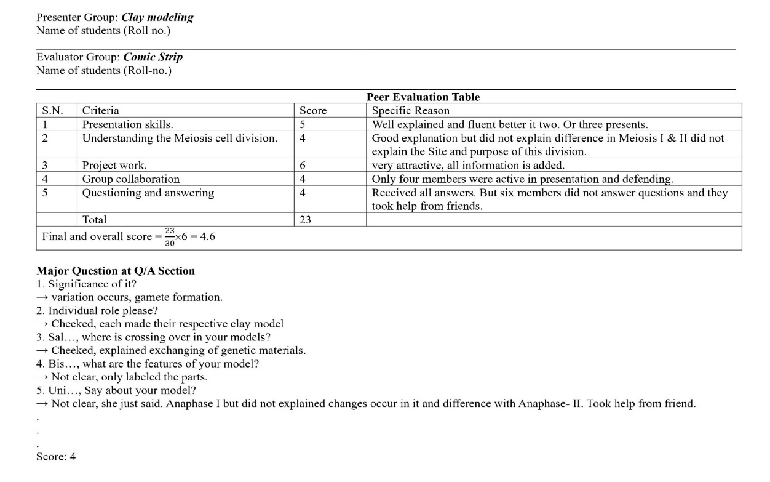
Figure 5a: Peer Evaluation to the Presenter Group; Clay Modeling
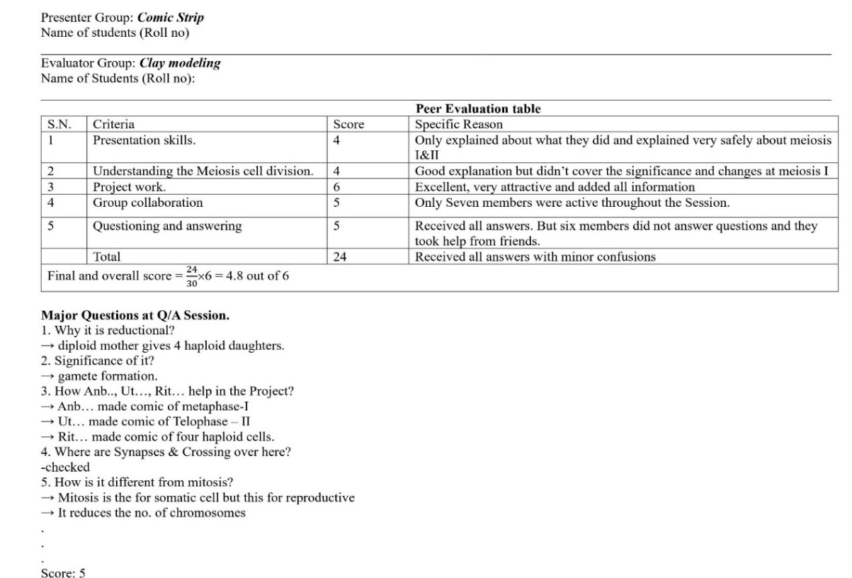
Figure 5b: Peer Evaluation to the Presenter Group; Comic Strip
Figure 6: Self and Intra-group Evaluation (A = Score bearer B = Score giver)
Figure 7: Teacher Evaluation

Grounded to the Challenges and Critiques of the Project:

Result and Discussion

So, obtaining scores from the peer and self-evaluation and myself, I wondered to test the relevancy or reliability of the student's scores on peer evaluation and set the hypothesis as:
Null hypothesis (H₀): There is no significant difference between the scores given by the teacher and the scores given by the evaluator group. In other words, the scores given by students are as reliable as those given by the teacher.

The scores obtained from me and the students seem the diverse assumptions for the statistic test. The population from which the sample was drawn was symmetric, observations were independent, and data paired and were taken from the same population and randomly chosen as explained by Kalpić et al. (2011); Rasch et al. (2011); Rey and Neuhäuser (2011); Taheri and Hesamian (2013); Zach (2021) which are mandatory assumptions for mean or median comparison between two scores. However, there is little difference between the scores given by two different evaluators in Table 2. Normality and homogeneity of variance are tested in Table 3 to validate the statistical test.
Table 2: Scores obtained by presenter group from teacher and evaluator group
 | Presenter: Comic Strip
Criteria | Presentation skills | Content delivery | Project work | Group Collaboration | Q/A session
Teacher | 4 | 3 | 5 | 4 | 3
Evaluator | 4 | 4 | 6 | 5 | 5
Difference1 | 0 | 1 | 1 | 1 | 2
Z-score | -1.41421 | 0.00 | 0.00 | 0.00 | 1.41421
 | Presenter: Clay Modeling
Teacher | 4 | 3 | 5 | 4 | 2
Evaluator | 5 | 5 | 6 | 4 | 4
Differnce2 | 1 | 2 | 1 | 0 | 2
Z-score | -0.23905 | 0.95618 | -0.23905 | -1.43427 | 0.95618
Z-value of differences in score are calculated by using SPSS software to check the outliers. All z-scores are lying between -3 to 3 which indicates no any outlier scores (PeruriVenkataAnusha et al., 2020).

Table 3: Tests of Normality and Symmetry
 |  |  | Shapiro-Wilk |  |  |  |  |  | Descriptives |  |  |  |  |  | ANOVA
 |  |  | Statistic |  | df |  | Sig. |  | Mean |  | Median | Skewness |  |  | F |  | Sig.
Difference 1 (Score obtained by Comic strip group from teacher and Clay modeling group) |  |  | .883 |  | 5 |  | .325 |  | 1 |  | 1 | 0.00 |  |  | 1.800 |  | 0.357
Difference 2 (Score obtained by Clay modeling group from teacher and Comic strip group) |  |  | .883 |  | 5 |  | .325 |  | 1 |  | 1 | 0.00 |  |  | 1.080 |  | 0.481
a. Lilliefors Significance Correction
Note: If sig. (p-value) > 0.05 at 95% level of significance then the score shows the normality (Normally distributed) and Homogeneity of variance elsewhere not.
Here, Sig. (p-value) of both score differences is greater than 0.05. Therefore, we can conclude that the difference score is normally distributed and homogeneity of variance among scores given by teacher and peer group. Moreover, 0 skewness indicates scores are symmetrical.

Scores meet the assumptions of normality and symmetry for student t-test (Kalpić et al., 2011; Rasch et al., 2011; Rey and Neuhäuser, 2011; Taheri and Hesamian, 2013; Zach, 2021)

Table 4: Statistical Test: Paired Samples Student t-test
 |  | Paired Differences |  |  |  |  |  |  |  |  |  |  | t | df |  | Sig. (2-tailed)
 |  | Mean |  | Std. Deviation |  | Std. Error Mean |  | 95% Confidence Interval of the Difference
 |  |  |  |  |  |  |  | Lower |  | Upper
Pair 1 | Teacher to clay Modeling - Comic Strip to Clay Modeling | -1.200 |  | .837 |  | .374 |  | -2.239 |  | -.161 |  |  | -3.207 | 4 |  | .033
Pair 2 | Teacher to Comic Strip - Clay modeling to Comic Strip | -1.000 |  | .707 |  | .316 |  | -1.878 |  | -.122 |  |  | -3.162 | 4 |  | .034
Note: If sig. (p-value) > 0.05 at 95% level of significance then we accept the null hypothesis.
* The t-values are -3.207 and -3.162. This is the calculated difference represented in units of standard error. The negative sign indicates that score given by me was lower mean score than the students’ peer group.

The p-value (Sig., 2-tailed) is 0.034 & 0.033 < 0.05. This means that the difference in scores between both groups’ evaluating is statistically significantly different than of mine, indicating more effort is required to make our evaluation uniform and reliable.

On critically reflecting on the session, the very day, I noticed the lack of monitoring to control the overcrowding, excess liberalization to students for group collaborations, and time-consuming discussion. I hypothesized that such could be due to the dilemma on the role and concept of some students that they weren’t identifying their next steps. This shows that a balance between Guidance and Exploration was lacking (Bell et al., 2010) and Bell et al. (2010) suggest, that the instructional level should be carefully calibrated so that it’s not too basic, which would result in learners gaining no new insights, and not too advanced, which could hinder learners from assimilating the information into their existing knowledge.

At times, I feel frustrated and think that if real-life visualization, observation, and measurement aren't available, explaining through images could be easier and quicker. Embracing change, I aim to integrate modern teaching methods over rote learning. As a STEAM practitioner, I acknowledge transformational challenges and strive to centralize STEAM principles in my teaching. Additionally, I'm exploring potential strategies to provide appropriate support, which could involve using diagnostic tools and establishing a team-building process with a clear shared vision. Additionally, I need to adapt and align with students’ progressive discussions to best fit their needs, rather than stifling their openness by enforcing a silent zone.

Regarding peer evaluation and art-based learning of meiosis division, students were unsure if their scores would be included in the terminal examination and about the aesthetic value of creating comic strips and clay models. This uncertainty arises especially when students are unfamiliar or perceived as inexperienced, leading to a reluctance to participate due to a lack of trust in practitioners (Christidou et al., 2022). The practice of peer/self-assessment was recently introduced, and students are still grappling with challenges such as subjective judgment, where personal biases or preconceptions can influence their evaluations, potentially leading to inaccurate or unfair assessments (Ndoye, 2017). Additionally, the influences of social, cultural, and educational backgrounds, and difficulties in grading (Gurbanov, 2016), can all impact the accuracy and reliability of evaluations.

The observed mean difference of -1.2 or -1 signifies that my scores were, on average, 1.2 or 1 point lower than those of the respective evaluating group. While this difference is statistically significant (Taheri and Hesamian, 2013; Zach, 2021), it’s crucial to contemplate whether a mean difference holds practical significance within the context of our scoring system.

In light of the evaluative contributions made by the students, and with the understanding that my role is that of a practitioner rather than an infallible adjudicator, we undertook modifications to the scoring system, practicing to address the power imbalance in learning society (Fleming, 2022). In the context of self and intra-group evaluation, I accounted for the potential influence of personal biases or preconceptions. To foster individuality, I permitted students to evaluate themselves. However, to prevent excessive subjectivity, I imposed a limit, restricting the score to a maximum of 3 out of 15.

This measure was crucial as it facilitated the cultivation of a positive rapport with the students, thereby fostering a conducive learning environment (Cayubit, 2022). Furthermore, this step was instrumental in promoting enhancements for future iterations of the same process, underscoring the importance of continuous learning and improvement (Gravett & Merwe, 2023). We added and subtracted 1 point from required criterion for statistically acceptance. This rectification not only aligns the mean scores of the two groups but also addresses the discrepancy, thereby enhancing the reliability of the scores.

Table 5: Adjusted scores obtained by presenter group from teacher and peer group
 | Presenter: Comic Strip
Criteria | Presentation skills | Content delivery | Project work | Group Collaboration | Q/A session | Final mean score | Sig. (2-tailed)
Teacher | 4 | 3 | 5 | 4 | 4 | 4 | 0.070
Evaluator | 4 | 4 | 6 | 4 | 5 | 4.6
Difference1 | 0 | 1 | 1 | 0 | 1 | 0.6
 | Presenter: Clay Modeling
Teacher | 4 | 3 | 5 | 4 | 3 | 3.8 | 0.070
Evaluator | 5 | 4 | 5 | 4 | 4 | 4.4
Differnce2 | 1 | 1 | 0 | 0 | 2 | 0.6

This approach underscores the importance of flexibility and mutual respect in the evaluation process, acknowledging that students bring valuable perspectives to the assessment of academic work. Moreover, by demonstrating adaptability and intentionality in my teaching practice, I was showing a commitment to creating a significant learning experience for my students (Gravett & Merwe, 2023). I firmly advocate for students’ peer evaluation, a viewpoint supported by Omelicheva (2005). This stance is largely due to my proactive involvement in directing their activities, where I offered mentorship opportunities and incremental practice (Atenas et al., 2023). Thereby, this approach may instill confidence in my students, reducing any apprehension about their future endeavors.

While employing the STEAM approach, students were able to conceptualize and defend an average of 4 or 5 out of 6 points. In contrast, a more instructive or rote learning approach might have enabled students to achieve a perfect score of 6 out of 6 since I know the learning and memorizing ability of my students. Moreover, it is a complex and more time and effort-investing approach, a big question may arise here; is it worth it?

However, it's crucial to reflect on what we truly value in education. The goal of the STEAM approach is not merely to recall facts but to foster a deeper comprehension and application of knowledge. This approach promotes critical thinking, calculated risk, creativity, collaboration, and problem-solving skills (Bertrand & Namukasa, 2020; Perales & Aróstegui, 2021), which are often overlooked in rote learning but are essential for real-world applications (Land, 2013). Therefore, this transcends the conventional discourse on worthiness.

Moreover, I found this approach also covers those students who have lower or least ability of rote learning to foster their collaborative, hands-on, decision-making, critical thinking, and communicative skills. Indeed, these skills including the ability to convert an abstract concept into a tangible product or action form the crux of innovation and hold immense practical value (Herro et al., 2017; Bertrand & Namukasa, 2020; Wu et al., 2022; Aydın Gürler & Kaplan, 2023). Furthermore, in the line of Schena et al. (2023), the competencies needed to articulate and defend one’s work are essential in a variety of real-life situations, from delivering professional presentations to advocating for oneself.

Drawing upon the prime cognition of “STEAM in Education” (2021) and Wu et al. (2022), I assert that although the scores may seem lower with the STEAM approach, the learning outcomes - in terms of skill development, conceptual understanding, and real-life application - could be significantly richer and more advantageous for students in the long run. Furthermore, it's essential to self-reflect on what we are preparing our students for and how we are approaching it. This reflection is key to ensuring that our teaching methods align with our educational goals.

Research Implication:

The research underscores the significance of a holistic learning environment integrating diverse disciplines in science education, achieved through the amalgamation of diverse activities (e.g., Land, 2013: Perales & Aróstegui, 2021), thereby advocating for a heterogeneous and inclusive pedagogical strategy. A key focus is placed on the cognitive, affective learning, and psychomotor domains, which are seen as instrumental in augmenting students' comprehension of intricate scientific concepts and nurturing a sense of affiliation and accountability towards their projects rather than the abstract memorizing (e.g., Herro et al., 2017; Bertrand & Namukasa, 2020; STEAM in Education, 2021; Wu et al., 2022; Aydın Gürler & Kaplan, 2023) in the context of meiosis cell division, emphasizing the competencies needed to articulate and defend one’s work in a variety of real-life situations.. Moreover, it highlights the criticality of collaboration and peer evaluation (e.g., Omelicheva, 2005; Atenas et al., 2023), emphasizing the importance of collective efforts and individual roles within the learning process.

The research advocates, as suggested by Tuomainen (2023), for the need to adapt and align with students’ progressive discussions to best accommodate their needs, suggesting a shift towards a more learner-centric approach to teaching. It also recognizes the importance of addressing the power imbalance between teachers and students in the learning and assessing process, suggesting a move towards a more equitable approach to assessment. This cultivates a positive rapport with students and is seen as crucial in fostering a conducive learning environment (Zhou, 2021). This is further reinforced by the importance placed on flexibility and mutual respect in the evaluation process (e.g., Cayubit, 2022; Fleming, 2022; Gravett & Merwe, 2023), underscoring the need for a more inclusive and learner-centric approach to assessment.

Research Limitation:

To begin with, the study appears to be primarily based on personal reflections and observations, which may lack the empirical evidence necessary for theorizing the findings (Alt & Raichel, 2022). This reliance on personal experiences and perceptions could introduce a degree of subjectivity, potentially limiting the objectivity and reliability of the results (Brown, 2019), however, they also provide valuable insights into the lived experiences (Gransden, 2004). In addition, the scope of the research is limited, focusing on a specific educational setting (STEM) and a particular group of students. This focus could restrict the applicability of the findings to other settings (Li et al., 2020) or student populations (humanities, special education, online, and so on).

Moreover, the study encountered challenges associated with implementing the STEAM approach. In addition to Hsu and Fang (2019), the need for more time, effort, and resources could limit its effectiveness and feasibility in certain educational settings (Delia Voicu et al., 2023). Time constraints were particularly noticeable, with class periods ending before tasks were completed, which could limit the learning process and put additional pressure on students to complete their work at home.

Furthermore, the practice of self-evaluation could introduce bias, as students might overestimate or underestimate their abilities, affecting the accuracy of the evaluations (Gurbanov, 2016; Ndoye, 2017). Uncertainty about the value of peer evaluation and art-based learning (Christidou et al., 2022), and personal biases or preconceptions can influence peer/self-assessments (Ndoye, 2017), potentially leading to inaccurate or unfair assessments. The practice of adding or subtracting 1 point from the required criterion for statistical acceptance could introduce additional bias in the evaluation process.

Future Direction:

Future research could concentrate on several pivotal areas to enhance this study. Addressing the challenges and expanding the research scope associated with the STEAM approach is one such area (e.g., Li et al., 2020; Hsu & Fang, 2019; Delia Voicu et al., 2023), which could involve strategizing to minimize resource requirements and increase feasibility across diverse educational settings (e.g., Bell et al., 2010). Refinement of self-evaluation and peer evaluation practices that could further formulate explicit guidelines (e.g., Mariya, 2005; Yang et al., 2019), offer student training, and devise strategies to mitigate bias in evaluations, thereby enhancing their accuracy and fairness and could strive to amass more empirical evidence to substantiate the findings (Alt & Raichel, 2022). This could entail conducting rigorous quantitative studies or employing mixed methods research, thereby bolstering the results' validity.

Undertaking longitudinal studies could yield insights into the long-term effects and efficacy of the proposed pedagogical strategies, providing a more holistic understanding of their temporal impact (e.g., STEAM in Education, 2021; Delia Voicu et al., 2023). These directions could significantly augment the field and foster more effective and inclusive educational practices.

Conclusion

Invoking the wisdom of the great physicist J. Robert Oppenheimer (1904-67), that diverse theories of modern pedagogy only guide us so far. Real-world implementation involves unpredictable interpersonal experiences of challenges and insights. However, self-awareness and critical self-reflection (e.g., Gransden, 2004; Helyer, 2015; Miller & Verhaeghen, 2022) on these experiences allow for continual refinement of teaching practices, enhancing sustainable learning effectiveness.

Through this study, I found that students can gain aesthetic value from their creative arts, and we can acknowledge their self-evaluating work through critical reflection on the implementation of the STEAM project plan. It was grounded in progressive learning theory and pragmatism to construct and generate knowledge from the experiences of implementation. This study primarily highlights the complexities and challenges encountered while implementing the STEAM approach in science education. Despite these, I assert that the learning outcomes in terms of skill development, conceptual understanding, and real-life application could be significantly richer and more advantageous for students in the long run. In addition, this reflection underscores the importance I place on flexibility, mutual respect, adaptability, and intentionality in my teaching practice. It also emphasizes the value I see in peer evaluation and the role I play as a teacher in guiding students’ activities and providing mentorship.

ACKNOWLEDGEMENT

I would like to express my deepest gratitude to Kathmandu University: School of Education for offering the course that served as the foundation for this study and also immensely grateful to Kaligandaki Academy for providing me with the opportunity to implement my project. The experience I gained from this implementation was crucial in shaping my perspectives and enhancing my skills.

My sincere thanks go to Dr. Roshani Rajbanshi, the course facilitator, for her guidance, support, and invaluable insights throughout the course. Lastly, I would like to extend my heartfelt appreciation to the tenth graders who participated in my project. Their enthusiasm and cooperation made this project an enriching experience. Their contributions were instrumental in the success of my project.

Conflict of Interests: This work was conducted with full personal interest and self-funding for all requirements, including course fees and materials for the implementation of the STEAM project. Therefore, it is declared that there are no financial conflicts of interest that could have influenced the work reported in this paper.

Ethical Approval: Written approval following verbal conformation for this study was obtained from research committee at Kathmandu University to promote the learning outcomes from the course, STEAM ED 630 Teaching and Learning.

Informed Consent: Written consent along with written data was taken following the verbal agreement from participating students and school’s admin.

Data Organization: All data and materials used in this study are accurately retrieved (in digital form) from the original source and are securely stored with additional photographs, handwritten records, signed consent forms, and ethical clearance documents.

Funding: Not Applicable

REFERENCES

Ahmad, A., Kamin, Y., & Md.Nasir, A. N. (2018). Applying Psychomotor Domain for Competency-Based Teaching in Vocational Education. Journal of Physics: Conference Series, 1049(1), 012049. https://doi.org/10.1088/1742-6596/1049/1/012049
Alt, D., & Raichel, N. (2022). Higher Education Students’ Reflective Journal Writing and Lifelong Learning Skills: Insights From an Exploratory Sequential Study. Frontiers in Psychology, 12, 707168. https://doi.org/10.3389/fpsyg.2021.707168
Atenas, J., Nerantzi, C. and Bussu, A., (2023). A Conceptual Approach to Transform and Enhance Academic Mentorship: Through Open Educational Practices. Open Praxis, 15(4), p.271–287.DOI: https://doi.org/10.55982/openpraxis.15.4.595
Aydın Gürler, S. & Kaplan, O. (2023). Attitudes Towards STEAM, Critical Thinking Disposition and Decision-Making Skills: Mediation and Gender Moderation. International Journal of Contemporary Educational Research, 10(1), 210-223. https://doi.org/10.33200/ijcer.1272051
Belbase, S. (2019). STEAM Education Initiatives in Nepal. The STEAM Journal, 4(1), Article 7. https://doi.org/10.5642/steam.20190401.07
Bercht, M., Ramirez, A., & Fagundes, L. (2006). Pedagogical agents with affective and cognitive dimensions. ResearchGate. https://doi.org/10.13140/RG.2.1.2288.1762
Bertrand, M.G. and Namukasa, I.K. (2020), "STEAM education: student learning and transferable skills", Journal of Research in Innovative Teaching & Learning, Vol. 13 No. 1, pp. 43-56. https://doi.org/10.1108/JRIT-01-2020-0003
Bittermann, A., McNamara, D., Simonsmeier, B.A., & Schneider, M. (2023). The Landscape of Research on Prior Knowledge and Learning: a Bibliometric Analysis. Educ Psychol Rev 35, 58. https://doi.org/10.1007/s10648-023-09775-9
Bogna, F., Raineri, A. and Dell, G. (2020), "Critical realism and constructivism: merging research paradigms for a deeper qualitative study", Qualitative Research in Organizations and Management, Vol. 15 No. 4, pp. 461-484. https://doi.org/10.1108/QROM-06-2019-1778
Burns, M., Bally, J., Burles, M., Holtslander, L., & Peacock, S. (2022). Constructivist Grounded Theory or Interpretive Phenomenology? Methodological Choices Within Specific Study Contexts. International Journal of Qualitative Methods, 21, 1-13. https://doi.org/10.1177/16094069221077758
Brookhart, S. M. (2018). Appropriate Criteria: Key to Effective Rubrics. Frontiers in Education, 3, Article 359715. https://doi.org/10.3389/feduc.2018.00022
Brown, S.R. (2019). Subjectivity in the Human Sciences. Psychol Rec 69, 565–579. https://doi.org/10.1007/s40732-019-00354-5
Cayubit, R.F.O. (2022). Why learning environment matter? An analysis on how the learning environment influences the academic motivation, learning strategies and engagement of college students. Learning Environ Res 25, 581–599. https://doi.org/10.1007/s10984-021-09382-x
Christidou, D., Voulgari, I., Tisza, G., Norouzi, B., Kinnula, M., Iivari, N., Papavlasopoulou, S., Gollerizo, A., González, J. M. L., & Sofrona, D. K. (2022). Obstacles and challenges identified by practitioners of non-formal science learning activities in Europe. International Journal of Science Education, 44(3), 514-533. https://doi.org/10.1080/09500693.2022.2035466
Delia Voicu, C., Ampartzaki, M., Yilmaz Dogan, Z., & Kalogiannakis, M. (2023). STEAM Implementation in Preschool and Primary School Education: Experiences from Six Countries. IntechOpen. doi: 10.5772/intechopen.107886
Deng, Y., Kelly, G. J., & Deng, S. (2019). The influences of integrating reading, peer evaluation, and discussion on undergraduate students’ scientific writing. International Journal of Science Education, 41(10), 1408-1433. https://doi.org/10.1080/09500693.2019.16108111
Denzin, N.K. and Lincoln, Y. (Eds) (2013), The Landscape of Qualitative Research, 4th ed., SAGE Publications, Thousand Oaks, California, CA.
Dhamala, M. K., Koirala, M., Khatiwada, R. P., & Deshar, R. (2021). Bottlenecks in Expanding Science and Technology Education in Nepal: An Exploratory Study. Education Research International, Article ID 8886941. https://doi.org/10.1155/2021/8886941
Fayek, H. M., Cavedon, L., & Wu, H. R. (2020). Progressive learning: A deep learning framework for continual learning. Neural Networks, 128:28:345-357. https://doi.org/10.1016/j.neunet.2020.05.011
Fenstermacher, G. D., & Soltis, J. F. (2009). Approaches to Teaching. In J. F. Soltis (Ed.), Approaches to Teaching (4th ed., pp. 1-10). Teachers College Press.
Fleming, T. (2022). Transformative Learning and Critical Theory: Making Connections with Habermas, Honneth, and Negt. In: Nicolaides, A., Eschenbacher, S., Buergelt, P.T., Gilpin-Jackson, Y., Welch, M., Misawa, M. (eds) The Palgrave Handbook of Learning for Transformation. Palgrave Macmillan, Cham. https://doi.org/10.1007/978-3-030-84694-7_2
Fitzgerald, A., & Smith, K. (2016). Science that Matters: Exploring Science Learning and Teaching in Primary Schools. Australian Journal of Teacher Education, 41(4). https://doi.org/10.14221/ajte.2016v41n4.4
Gauthier, L. (2014). How Learning Works: 7 Research-Based Principles for Smart Teaching. Journal of the Scholarship of Teaching and Learning. 14(1). 126. DOI:10.14434/josotl.v14i1.4219
George, T. (2023). What is Action Research? | Definition & Examples. Scribbr. Retrieved from https://www.scribbr.com/methodology/action-research/
Gilbert, J., K. (2012). A coherent approach to the development of science education Science learning and instruction: Taking advantage of technology to promote knowledge integration. Studies in Science Education, 48(2), 217–221. http://dx.doi.org/10.1080/03057267.2012.720769
Graham, O. (2013). The content, consequence and likeness approaches to verisimilitude: compatibility, trivialization, and underdetermination. Synthese, 190(9), 1647–1687. https://doi.org/10.1007/s11229-011-9930-8
Gransden, B. (2004). Reflections on teaching observations and the use of a personal development journal in medical teacher education, Educational Action Research, 12:1, 19-32, DOI: 10.1080/09650790400200237
Gravett, S., & Merwe, D. van der. (2023) Learning-centered lesson design and learning about teaching in a pre-service teacher education course. Cogent Education, 10:1, DOI: 10.1080/2331186X.2023.2202123
Grob, R., Holmeier, M., & Labudde, P. (2021). Analysing formal formative assessment activities in the context of inquiry at primary and upper secondary school in Switzerland. International Journal of Science Education, 43(3), 407-427. https://doi.org/10.1080/09500693.2019.1663453
Green, Z. A., & Batool, S. (2017). Emotionalized learning experiences: Tapping into the affective domain. Evaluation and Program Planning, 62, 35-48. DOI: 10.1016/j.evalprogplan.2017.02.004
Gurbanov, E. (2016). The Challenge of Grading in Self and Peer-Assessment (Undergraduate Students’ and University Teachers’ Perspectives). Journal of Education in Black Sea Region, 1(2), 82-91. Retrieved from ED569122.pdf
Guy, G. M., Cornick, J., & Beckford, I. (2015). More than Math: On the Affective Domain in Developmental Mathematics. International Journal for the Scholarship of Teaching and Learning, 9(2), Article 7. https://doi.org/10.20429/ijsotl.2015.090207
Helyer, R. (2015). Learning through reflection: The critical role of reflection in work-based learning (WBL). Journal of Work-Applied Management, 7(1), 15-27. https://doi.org/10.1108/JWAM-10-2015-003
Herodotou, C., Sharples, M., Gaved, M., Rienties, B., Scanlon, E., & Whitelock, D. (2019). Innovative Pedagogies of the Future: An Evidence-Based Selection. Frontiers in Education, 4, 476104. https://doi.org/10.3389/feduc.2019.00113
Herro, D., Quigley, C., Andrews, J., & Delacruz, G. (2017). Co-Measure: Developing an assessment for student collaboration in STEAM activities. International Journal of STEM Education, 4(1), 1-12. https://doi.org/10.1186/s40594-017-0094-z
Holbrook, J., Rannikmäe, M., & Soobard, R. (2020). STEAM Education—A Transdisciplinary Teaching and Learning Approach. In: Akpan, B., Kennedy, T.J. (eds) Science Education in Theory and Practice. Springer Texts in Education. Springer, Cham. https://doi.org/10.1007/978-3-030-43620-9_31
Hoque, M. E. (2016). Three Domains of Learning: Cognitive, Affective, and Psychomotor. ResearchGate. ISSN-2520-5897. (PDF) Three Domains of Learning: Cognitive, Affective and Psychomotor (researchgate.net)
Hunter, L., & Frawley, E. (2023). Engaging students using an arts-based pedagogy: teaching and learning sociological theory through film, art, and music. Teaching Sociology, 51(1), 13-25. https://doi.org/10.1177/0092055X221096657
Hsu, YS. & Fang, SC. (2019). Opportunities and Challenges of STEM Education. In: Hsu, YS., Yeh, YF. (eds) Asia-Pacific STEM Teaching Practices. Springer, Singapore. https://doi.org/10.1007/978-981-15-0768-7_1
Jacobs, R. (2022). Arts-based critical service-learning experiences as transformative pedagogy. Journal of Pedagogy, 29-53. https://doi.org/10.2478/jped-2022-0007
Jin, Y. Q., Lin, C., Zhao, Q., Yu, S., & Su, Y. (2021). A Study on Traditional Teaching Method Transferring to E-Learning Under the Covid-19 Pandemic: From Chinese Students' Perspectives. Frontiers in Psychology, 12, 632787. https://doi.org/10.3389/fpsyg.2021.632787
Kalpić, D., Hlupić, N., Lovrić, M. (2011). Student’s t-Tests. In: Lovric, M. (eds) International Encyclopedia of Statistical Science. Springer, Berlin, Heidelberg. https://doi.org/10.1007/978-3-642-04898-2_641
Kelly, L. M., & Cordeiro, M. (2020). Three principles of pragmatism for research on organizational processes. Methodological Innovations, 13(2). https://doi.org/10.1177/2059799120937242
Kitchenham, A. (2012). Jack Mezirow on Transformative Learning. In: Seel, N.M. (eds) Encyclopedia of the Sciences of Learning. Springer, Boston, MA. https://doi.org/10.1007/978-1-4419-1428-6_362
Koirala, K., P. (2021). Multimodal Classroom Teaching in Nepal: Perspectives and Practices of a Secondary Level Science Teacher. Cultural Studies of Science Education 16(3) DOI: 10.1007/s11422-020-10012-w
Kpum, M. M. Agi, C. I., & Aduloju, M. O. (2018). Beyond Cognitive Assessment: Teachers Attitudes towards Assessing Psychomotor and Affective Domains of Students’ Behaviors in Classrooms in North Central-Nigeria. Journal of Education and Practice, 9(16). Retrieved from JEP-Vol.9 No.16 2018 (iiste.org)
Land, M. H. (2012). Full STEAM Ahead: The Benefits of Integrating the Arts Into STEM. Procedia Computer Science, 20, 547-552. https://doi.org/10.1016/j.procs.2013.09.317
Li, Y., Wang, K., Xiao, Y., & Froyd, J. E. (2020). Research and trends in STEM education: a systematic review of journal publications. International Journal of STEM Education, 7(11). https://doi.org/10.1186/s40594-020-00207-6
MacNeill, V., Foley, M., & Quirk, A. (2016). Shedding light on research participation effects in behaviour change trials: a qualitative study examining research participant experiences. BMC Public Health 16, 91. https://doi.org/10.1186/s12889-016-2741-6
Menin, A., & Testa, I. (2021). From STEM to STEAM: An Enactive and Ecological Continuum. Frontiers in Education, 6. https://doi.org/10.3389/feduc.2021.709560
Miller, J. T., & Verhaeghen, P. (2022). Mind full of kindness: Self-awareness, self-regulation, and self-transcendence as vehicles for compassion. BMC Psychology, 10, 188. https://doi.org/10.1186/s40359-022-00888-4
Mohammed, M., & Omar, N. (2020). Question classification based on Bloom’s taxonomy cognitive domain using modified TF-IDF and word2vec. PLOS ONE, 15(3), e0230442. https://doi.org/10.1371/journal.pone.0230442
Ndoye, A. (2017). Peer/Self -Assessment and Student Learning. International Journal of Teaching and Learning in Higher Education, 29(2), 255-269. Retrieved from Microsoft Word - IJTLHE 2594.doc (ed.gov)
Omelicheva, M. Y. (2005). Self and Peer Evaluation in Undergraduate Education: Structuring Conditions That Maximize Its Promises and Minimize the Perils. Journal of Political Science Education, 1(2), 191-205. https://doi.org/10.1080/15512160590961784
Ozkan, G. & Topsakal, U., U. (2021) Investigating the effectiveness of STEAM education on students’ conceptual understanding of force and energy topics, Research in Science & Technological Education, 39:4, 441-460, DOI: 10.1080/02635143.2020.1769586
Palmer, B. W. (2021). Informed consent. In S. Panicker & B. Stanley (Eds.), Handbook of research ethics in psychological science (pp. 55–71). American Psychological Association. https://doi.org/10.1037/0000258-004
Perales, F. J., & Aróstegui, J. L. (2021). The STEAM approach: Implementation and educational, social and economic consequences. Arts Education Policy Review. https://doi.org/10.1080/10632913.2021.1974997.
PeruriVenkataAnusha, Ch.Anuradha, Patnala S.R. Chandra Murty, & Ch. Surya Kiran. (2020). Detecting Outliers in High Dimensional Data Sets Using Z-Score Methodology. International Journal of Innovative Technology and Exploring Engineering (IJITEE), 9(1). DOI: 10.35940/ijitee.A3910.119119
Peters, L., Pressey, A., Vanharanta, M. and Jonston, W. (2013), “Constructivism and critical realism as alternative approaches to the study of business networks: convergences and divergences in theory and in research practice”, Industrial Marketing Management, Vol. 42, pp. 336-346, doi: 10.1016/j.indmarman.2013.02.003.
Quigley, C. F., Herro, D., King, E., & Plank, H. (2020). STEAM Designed and Enacted: Understanding the Process of Design and Implementation of STEAM Curriculum in an Elementary School. Journal of Science Education and Technology, 29(4), 499–518. doi:10.1007/s10956-020-09832-w
Rasch, D., Kubinger, K.D. & Moder, K. (2011). The two-sample t-test: pre-testing its assumptions does not pay off. Stat Papers 52, 219–231 doi:10.1007/s00362-009-0224-x
Rey, D., & Neuhäuser, M. (2011). Wilcoxon-Signed-Rank Test. International Encyclopedia of Statistical Science, 1658–1659. doi:10.1007/978-3-642-04898-2_616
Robertson, T. (2022). Teaching Nepali teachers to teach better. In Nepali Times. Teaching Nepali teachers to teach better | Nepali Times
Şahin, M., & Doğantay, H. (2018). Critical Thinking and Transformative Learning. Journal of Innovation in Psychology, Education and Didactics, 22(1), 103-114. ERIC. https://files.eric.ed.gov/fulltext/ED593584.pdf
Schena, D., Rosales, R. & Rowe, E. (2023). Teaching Self-Advocacy Skills: A Review and Call for Research. J Behav Educ 32, 641–689. https://doi.org/10.1007/s10864-022-09472-7
Shulman, L. S. (2005). Signature pedagogies in the professions. Daedalus, 134(3), 52-59. https://doi.org/10.1162/0011526054622015.
Strijbos, J. W., & Wichmann, A. (2018). Promoting learning by leveraging the collaborative nature of formative peer assessment with instructional scaffolds. European Journal of Psychology of Education, 33, 1–9. https://doi.org/10.1007/s10212-017-0353-x
Suzanne, M. & Margaret, M. M. (2021). The effectiveness of formative assessment: student views and staff reflections. Assessment & Evaluation in Higher Education, 46:1, 1-16, DOI: 10.1080/02602938.2020.1754761
Taber, K. S. (2015). Meeting Educational Objectives in the Affective and Cognitive Domains: Personal and Social Constructivist Perspectives on Enjoyment, Motivation and Learning Chemistry. In M. Kahveci & M. Orgill (Eds.), Affective Dimensions in Chemistry Education (pp. 3-27). Springer Berlin Heidelberg. https://doi.org/10.1007/978-3-662-45085-7_1
Taheri, S. M. & Hesamian, G. (2013). A generalization of the Wilcoxon signed-rank test and its applications. Statistical Papers, 54(2), 457–470. doi:10.1007/s00362-012-0443-4
Tippett, T. P., & Lee, J. J. (2019). Looking Back to Move Forward: Understanding Progressive Education in the 21st Century. Journal of Applied Learning in Higher Education, 8, 79-98. https://doi.org/10.1080/21507622.2019.1682515
Tuomainen, S. (2023). Student-Centred Teaching to Support Learning. In: Supporting Students through High-Quality Teaching. Springer Texts in Education. Springer, Cham. https://doi.org/10.1007/978-3-031-39844-5_5
Virtue, E. E., Maddox, G., & Pfaff, K. (2019). The Lasting Effects of Learning Communities. Learning Communities Research and Practice, 7(2), Article 6. Retrieved September 12, 2023, Retrieved from The Lasting Effects of Learning Communities (ed.gov)
Wang, Y. (2022). A Comparative Study on the Effectiveness of Traditional and Modern Teaching Methods. In A. Holl et al. (Eds.), ICHESS 2022, ASSEHR 720 (pp. 270–277). Atlantis Press. DOI: 10.2991/978-2-494069-89-3_32
Wang, M. (2022). Analyzing the Influence of College Aesthetic Education Teaching on College Students’ Innovation Ability and Artistic Literacy Based on Decision Tree Classification Model. Mobile Information Systems. https://doi.org/10.1155/2022/9587049
Wolf, K., & Stevens, E. (2007). The Role of Rubrics in Advancing and Assessing Student Learning. The Journal of Effective Teaching, 7(1), 3-14. Source URL: ERIC.ed.gov
Wu, C., Liu, C., & Huang, Y. (2022). The exploration of continuous learning intention in STEAM education through attitude, motivation, and cognitive load. International Journal of STEM Education, 9(1), 1-22. https://doi.org/10.1186/s40594-022-00346-y
Yang, K.-K., Lee, L., Hong, Z.-R., & Lin, H.-s. (2016). Investigation of effective strategies for developing creative science thinking. International Journal of Science Education, 38(13), 2133-2151. https://doi.org/10.1080/09500693.2016.1230685
Yew, E. H. J., & Goh, K. (2016). Problem-Based Learning: An Overview of its Process and Impact on Learning. Health Professions Education, 2(2), 75-79. https://doi.org/10.1016/j.hpe.2016.01.004
Zach. (2021). The Four Assumptions Made in a T-Test. Statology. https://www.statology.org/t-test-assumptions.
Zlabkova, I., Petr, J., Stuchlikova, I., Rokos, L., & Hospesova, A. (2021). Development of teachers’ perspective on formative peer assessment. International Journal of Science Education, 43(3), 428-448. https://doi.org/10.1080/09500693.2020.1713418
Zhou, X. (2021). Toward the Positive Consequences of Teacher-Student Rapport for Students' Academic Engagement in the Practical Instruction Classrooms. Frontiers in Psychology, 12, 759785. https://doi.org/10.3389/fpsyg.2021.759785
(2021). STEAM in education: A bibliometric analysis of performance and co-words in Web of Science. International Journal of STEM Education, 8(1), 1-21. https://doi.org/10.1186/s40594-021-00296-x

Author Information
Sudarsan Limbu
https://orcid.org/0009-0007-6090-668X
MPhil scholar at STEAM Department
School of Education Kathmandu University, Lalitpur 44700
Nepal
Contact e-mail: sudarsan_mpsteam22@kusoed.edu.np

