**Evaluation Instrument for the BioEnergetic Enhancement Play Cards (BEEP Cards)**

*Direction:* The following statements evaluate specific aspects of the BioEnergetics Enrichment Play Cards (*BEEP Cards)* on a scale of 1 to 5. Put a check ( ) on the box that accurately defines the way you feel regarding each statement.

**Scale:**

5 – Strongly Agree

4 – Agree

3 – Neutral

2 – Disagree

1 – Strongly Disagree

|  |  |  |  |  |  |  |
| --- | --- | --- | --- | --- | --- | --- |
| **Goals and Objectives** | | **Scale** | | | | |
| **5** | **4** | **3** | **2** | **1** |
| 1. | The purpose and rationale for the games are fully explained. |  |  |  |  |  |
| 2. | The goals and objectives of the games are clearly defined. |  |  |  |  |  |
| 3. | The games were thought provoking. |  |  |  |  |  |
| 4. | The games encouraged student interaction. |  |  |  |  |  |
| 5. | The games promoted discussion of key topics. |  |  |  |  |  |
| 6. | The BEEP Cards help with my recall of concepts/terms. |  |  |  |  |  |

|  |  |  |  |  |  |  |
| --- | --- | --- | --- | --- | --- | --- |
| **Design** | | **Scale** | | | | |
| **5** | **4** | **3** | **2** | **1** |
| 7. | Card size is appropriate. |  |  |  |  |  |
| 8. | The terms printed on the two sides of the card are a helpful feature for the player’s handling of the cards. |  |  |  |  |  |
| 9. | The picture printed on the cards is representative of the topic. |  |  |  |  |  |
| 10. | The material used (paper) in the preparation of the cards is durable. |  |  |  |  |  |
| 11. | The deck of card is compact and can be easily carried around. |  |  |  |  |  |

|  |  |  |  |  |  |  |
| --- | --- | --- | --- | --- | --- | --- |
| **Components and Organization** | | **Scale** | | | | |
| **5** | **4** | **3** | **2** | **1** |
| 12. | The directions were clear, concise, and easily understood. |  |  |  |  |  |
| 13. | The games emphasized key points of the topic played. |  |  |  |  |  |
| 14. | The terms used were appropriate to my level of knowledge. |  |  |  |  |  |
| 15. | The number of cards was appropriate. |  |  |  |  |  |
| 16. | The length of time required to play each game is reasonable. |  |  |  |  |  |

|  |  |  |  |  |  |  |
| --- | --- | --- | --- | --- | --- | --- |
| **Playability/Playfulness** | | **Scale** | | | | |
| **5** | **4** | **3** | **2** | **1** |
| 17. | The games provide opportunity for healthy competition and cooperation. |  |  |  |  |  |
| 18. | The rules of the games provide players with equal conditions for a fair play. |  |  |  |  |  |
| 19. | The rules of the games provide a set of options for flexibility in making decisions towards playing the games. |  |  |  |  |  |
| 20. | Playing the games was fun. |  |  |  |  |  |

|  |  |  |  |  |  |  |
| --- | --- | --- | --- | --- | --- | --- |
| **Knowledge Acquisition** | | **Scale** | | | | |
| **5** | **4** | **3** | **2** | **1** |
| 21. | The games were effective in reviewing the concepts of the topics. |  |  |  |  |  |
| 22. | The games encouraged the players to dig deeper into the subject matter. |  |  |  |  |  |
| 23. | Playing the games is a productive use of time. |  |  |  |  |  |
| 24. | Playing the games help me establish better understanding of the concepts of the lesson. |  |  |  |  |  |
| 25. | I would recommend the games to my peers. |  |  |  |  |  |

Name of Evaluator: _______________________________________________________

Grade and Section: ______________________ Date: ______________________

Signature: _____________________________

**Interview Guide Questions**

1. Did you enjoy playing with the BEEP Cards? (please cite instances)

__________________________________________________________________________________________________________________________________________________________________________________________________________________________________________________________________________________________________________________________________________________________________________________________________________________________________________________________________________________________________________________________________________________________________

2. How did the BEEP Cards help you understand the concepts?

__________________________________________________________________________________________________________________________________________________________________________________________________________________________________________________________________________________________________________________________________________________________________________________________________________________________________________________________________________________________________________________________________________________________________

3. Do you think the use of BEEP Cards is more effective in learning the concepts than the use

of traditional methods such as paper-and-pencil? (please cite instances)

__________________________________________________________________________________________________________________________________________________________________________________________________________________________________________________________________________________________________________________________________________________________________________________________________________________________________________________________________________________________________________________________________________________________________

4. What are your suggestions to further improve the BEEP Cards?

__________________________________________________________________________________________________________________________________________________________________________________________________________________________________________________________________________________________________________________________________________________________________________________________________________________________________________________________________________________________________________________________________________________________________

Name of Interviewee: ________________________________________________________

Grade and Section: ______________________ Date: _________________­­­­________

Signature: _____________________________

**RATIONALE OF THE GAME**

The game was based on the popular card game Rummy as in the study of Gutierrez (2012). From the game from where it was patterned, the object is to lay down (meld) the five cards in one’s hands by combining cards to form pairs, three-of-a-kind, four-of-a-kind or five-of-a-kind.

Its major difference from the original game where it was patterned is that each of the cards that compose the deck of the BEEP Cards includes term lifted from the topics on bioenergetics. Instead of matching the face value of the cards or forming numerical straights, the players must form combinations that will demonstrate the relationship between or among the terms that are written on the cards.

The manner through which the player earn points depends on how well he can justify his card combinations in the order in which he declares them to the other players. This means that the players themselves are the referees of their game, while being facilitated by the teacher. This forces the students to be actively engaged in the task.

**Goals and Objectives of the Game**

The objective of this game is to promote small group discussion, problem-solving skills, independent thinking and active learning by applying basic concepts on bioenergetics in a fun and interactive setting.

**Playing the Game**

1. The game can be played by three to five (ideal number of players) players. From the group, one member will be assigned as dealer. The dealer will be the one in-charge of shuffling the deck and dealing each player 5 cards.
2. The dealer will then place the remaining cards in the deck face down at the center of the table, revealing the topmost card, and place it beside the deck. The player at the right of the dealer begins the game. The play continues in a counterclockwise direction.
3. The first player may choose the revealed card beside the deck or he may select the top card on the deck, depending upon potential combinations he may have in his present hand.
4. Upon selecting a card, a player in turn must discard one card, placing it face up beside the deck just like in the start of the play. Note that all discards should remain visible to all players as any one of these cards can be chosen in a player’s turn.
5. At this point, this player may pass play to the next player or declare “play” and lay down the cards which form a two- , three-, four- or five-card combination. The player must lay the cards in the exact order according to the relationship which he claims. .
6. Following the player’s justification of his organization of cards, the other players will then decide whether or not the combination and justification is valid. Should they unanimously approve of the cards laid down, the hand is scored as follows:

**Scoring System**

|  |  |
| --- | --- |
| **Card Combination** | **Points** |
| One 2-card combination | 2 points |
| One 3-card combination | 3 points |
| One 4-card combination  (two 2-card combination or 4-card combination in a single sequence) | 4 points |
| One 5-card combination  (one 2-card combination and one 3-card combination) | 5 points |
| One 5-card combination  (5-card combination in a single sequence) | 7 points |

Below are sample card combinations and justifications:

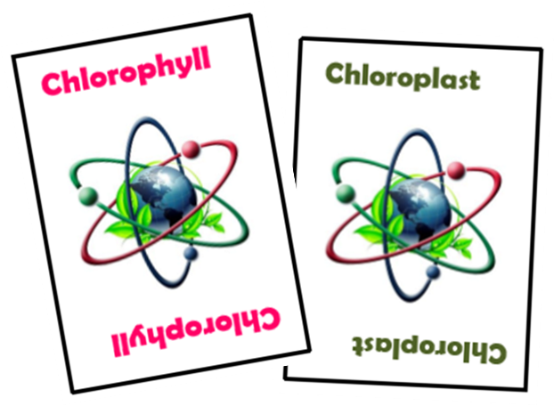

Justification: **Chlorophyll** is a pigment specifically found in the **chloroplast**.

**Sample Two-Card Combination**

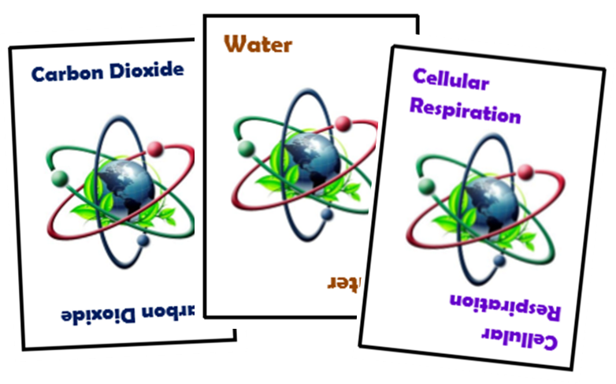

Justification: **Carbon dioxide** and **water** are produced in **cellular respiration**.

**Sample Three-Card Combination**

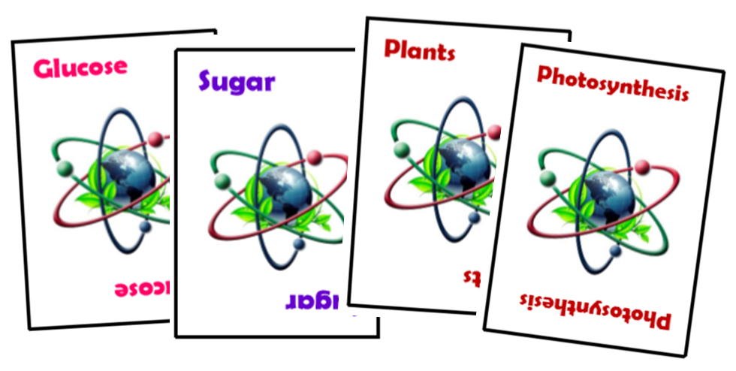

Justification: **Glucose** is a form of **sugar** produced by **plants** in the process of **photosynthesis**.

**Sample Four-Card Combination**

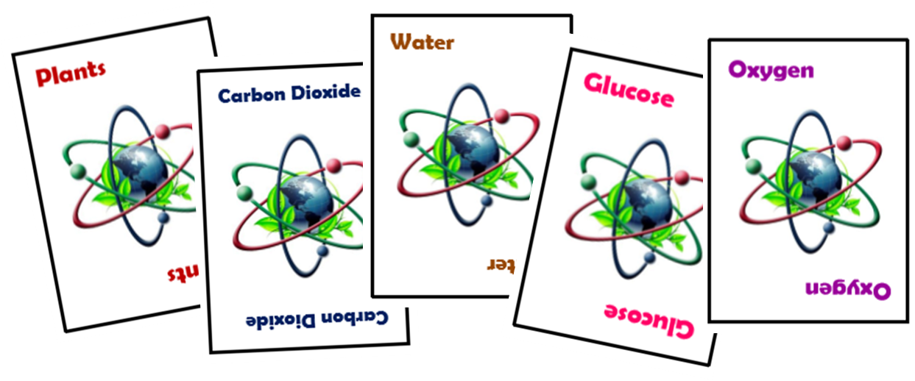

Justification: **Plants** use **carbon dioxide** and **water** to produce **glucose** and **oxygen**.

**Sample Five-Card Combination**

1. The player then draws the number of cards he played from the deck containing the face-down cards.
2. If the meld is not approved by the other players, each of the others receives one point, the player picks up his cards and play continues.
3. The turn ends when all the cards in the deck are gone, or when the time the players unanimously agreed upon to play the game has already lapsed.
4. The player with the highest point total is the winner.